Swinburne University of Technology

*COS20019 Cloud Computing Architecture*

*­­­*­­­­

Lab 2: Build a VPC and launch a Web Server

*Sunday 24th September, 2023*

Name: Phan Vu - ID: 104222099

**TASK 1: CREATE YOUR VPC**

5. Search for and choose VPC to open the VPC console.

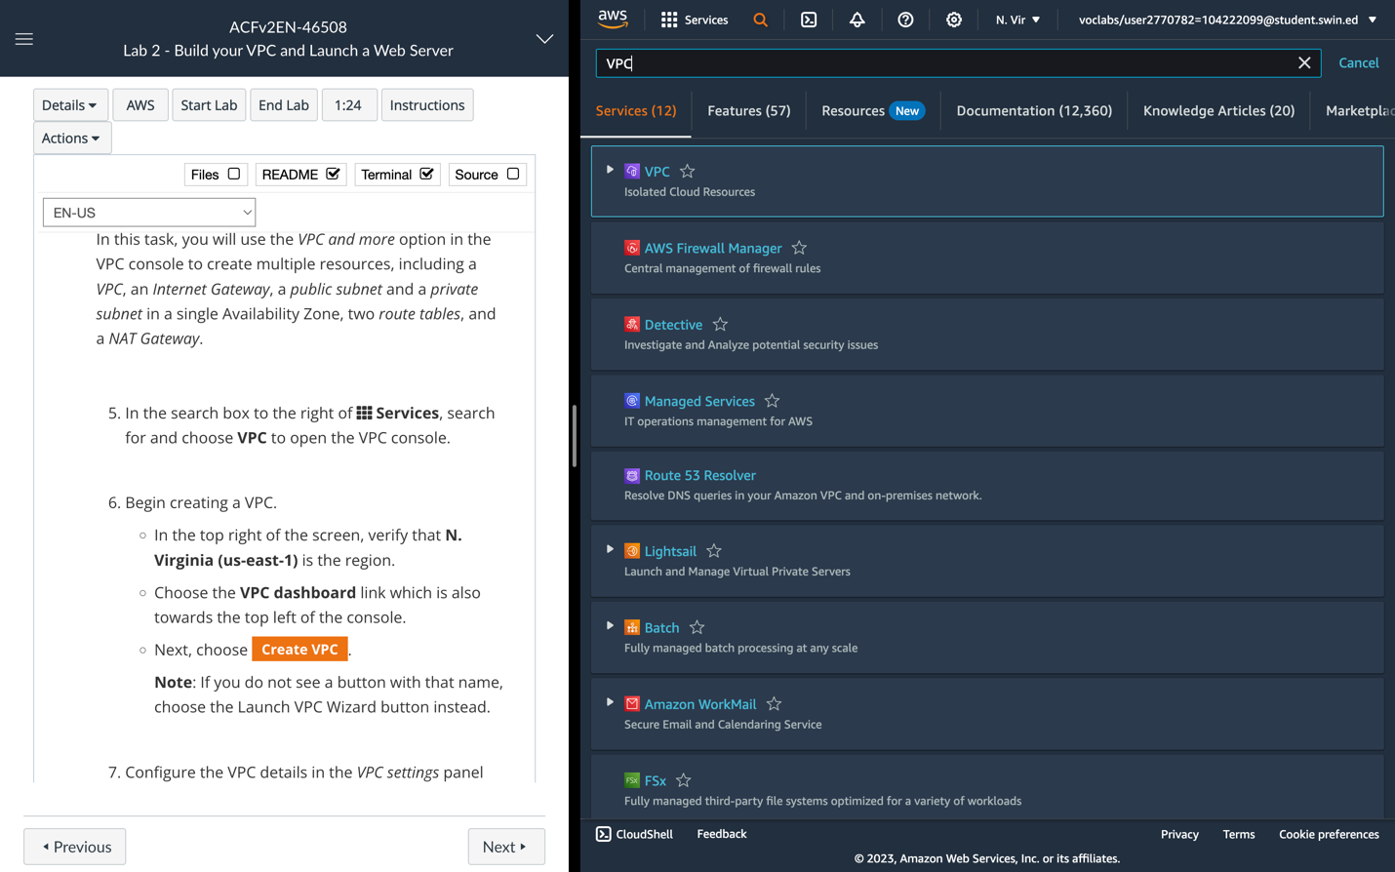

Searching for **VPC**

6. Begin creating a VPC.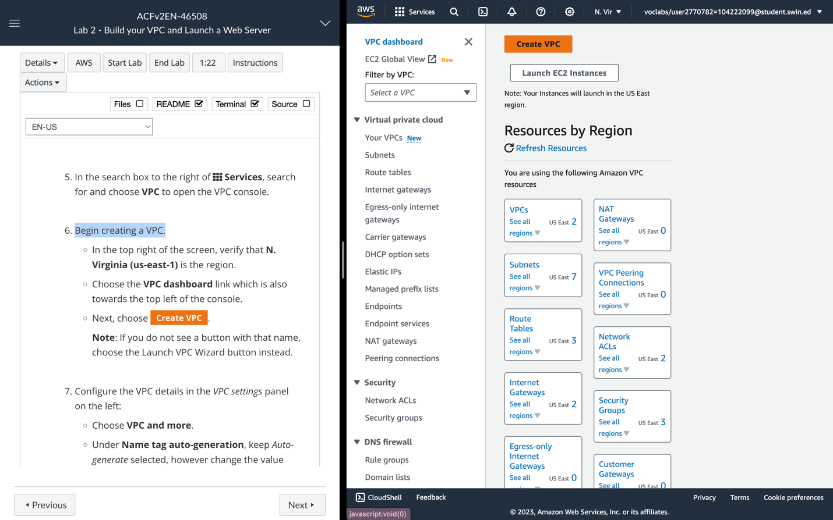

**VPC dashboard**

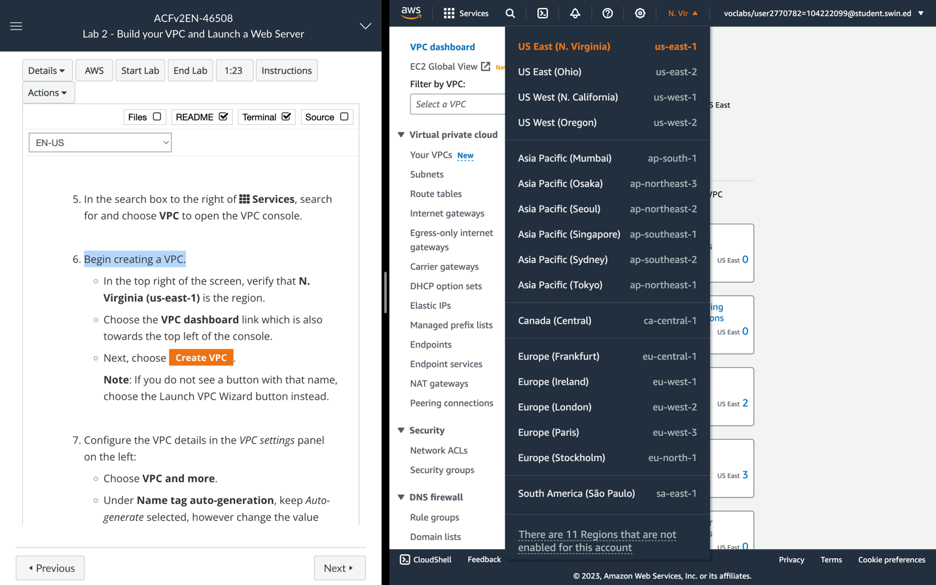

**N. Virginia (us-east-1)** is the region.

7. Configure the VPC details in the ***VPC settings*** panel on the left:

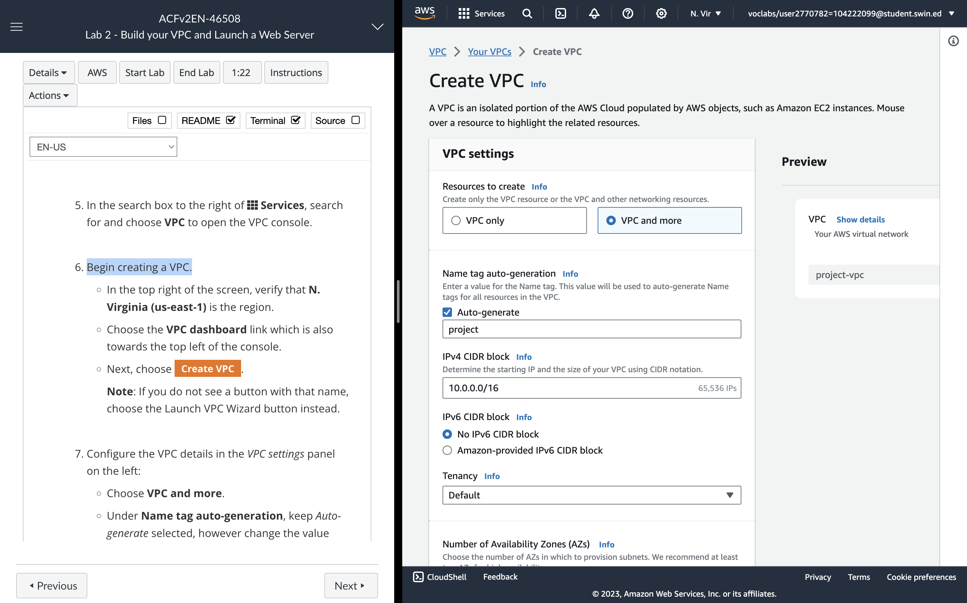

**VPC settings**

* Choose **VPC and more.**
* Under **Name tag auto-generation**, keep ***Auto-generate*** selected, however change the value from project to ***lab***.
* Keep the **IPv4 CIDR block** set to ***10.0.0.0/16***

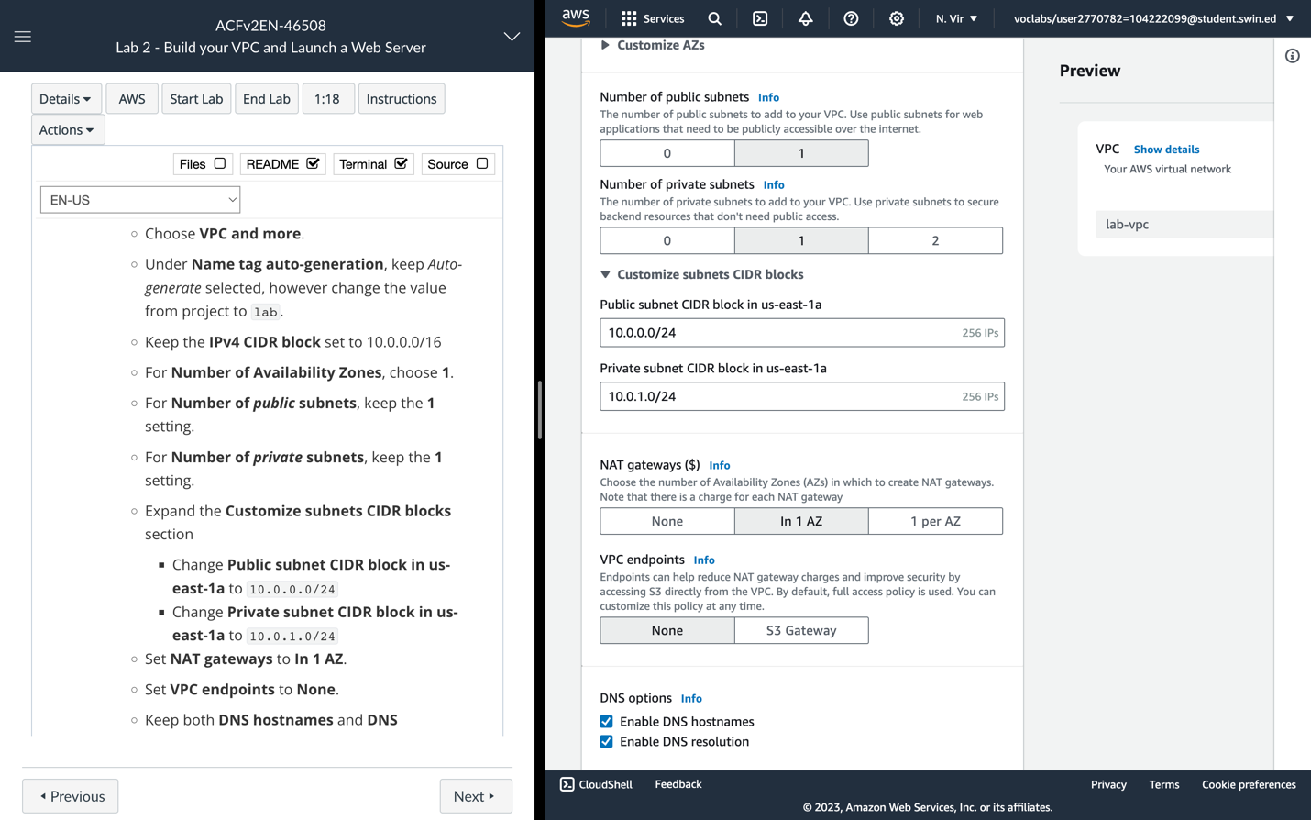

* For **Number of Availability Zones**, choose **1**.
* For **Number of public subnets**, keep the **1** setting.
* For **Number of private subnets**, keep the **1** setting.
* Expand the **Customize subnets CIDR blocks** section
  + Change **Public subnet CIDR block in us-east-1a** to ***10.0.0.0/24***
  + Change **Private subnet CIDR block in us-east-1a** to ***10.0.1.0/24***
* Set **NAT gateways** to ***In 1 AZ***.
* Set **VPC endpoints** to **None**.
* Keep both **DNS hostnames** and **DNS resolution** enabled.

8. Confirm the settings you have configured.

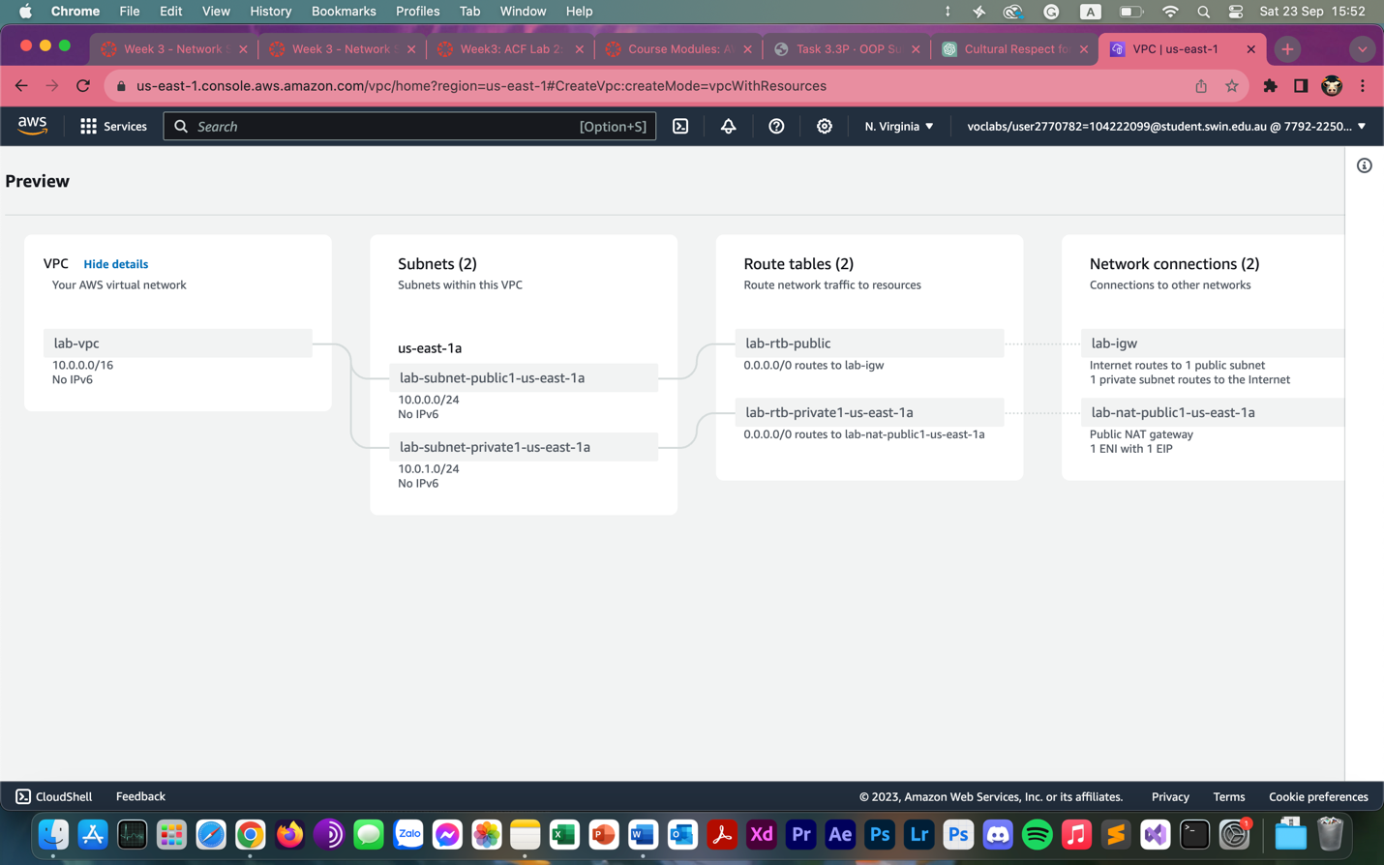

9. Choose “Create VPC”. The VPC resources are created.

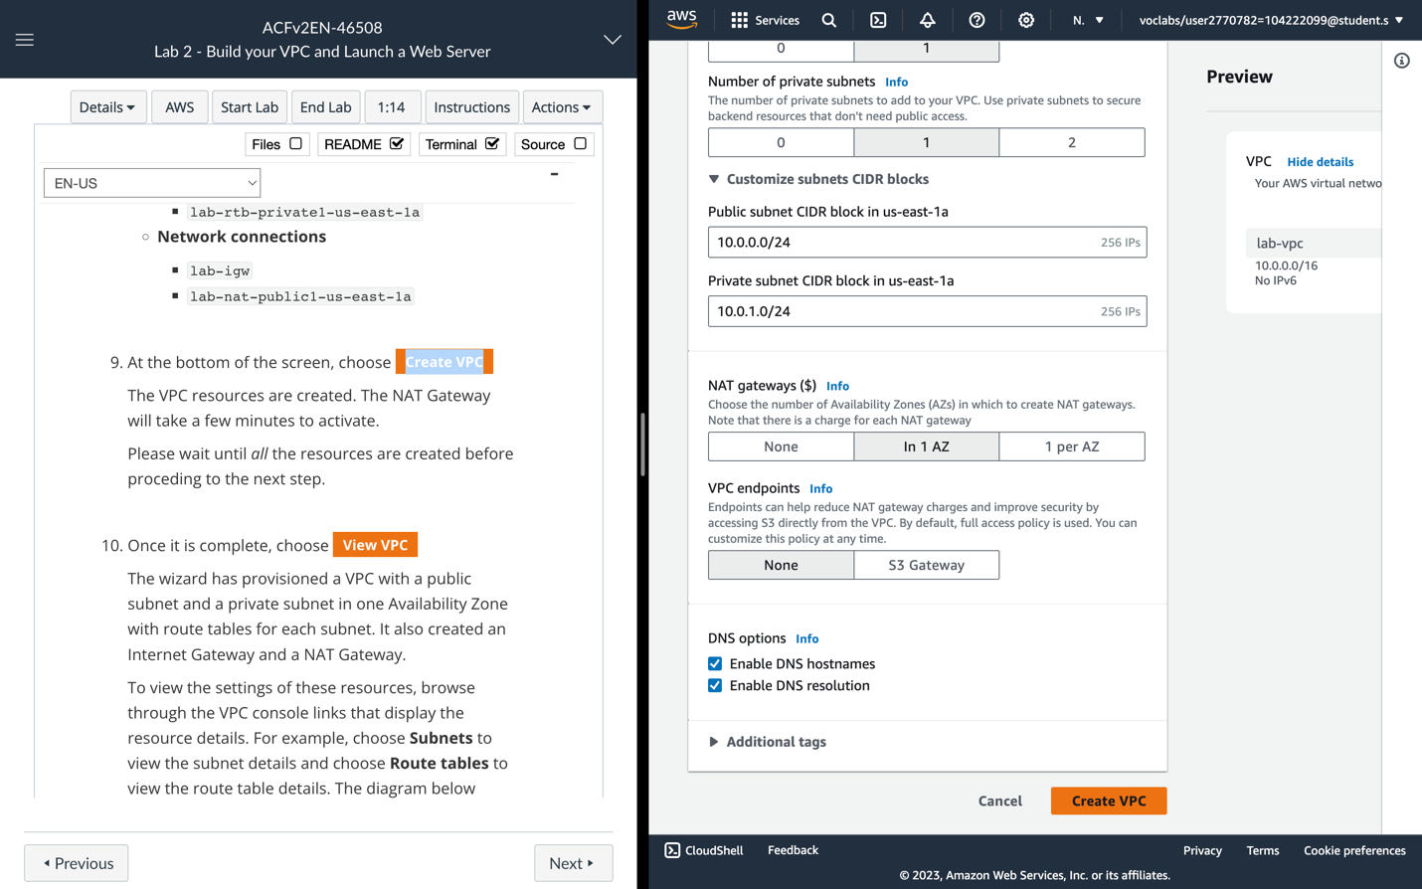

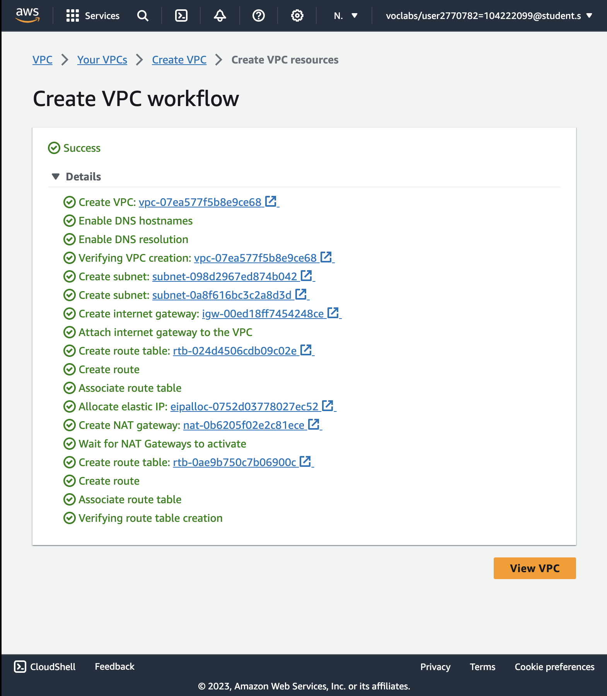

10. View **VPC**.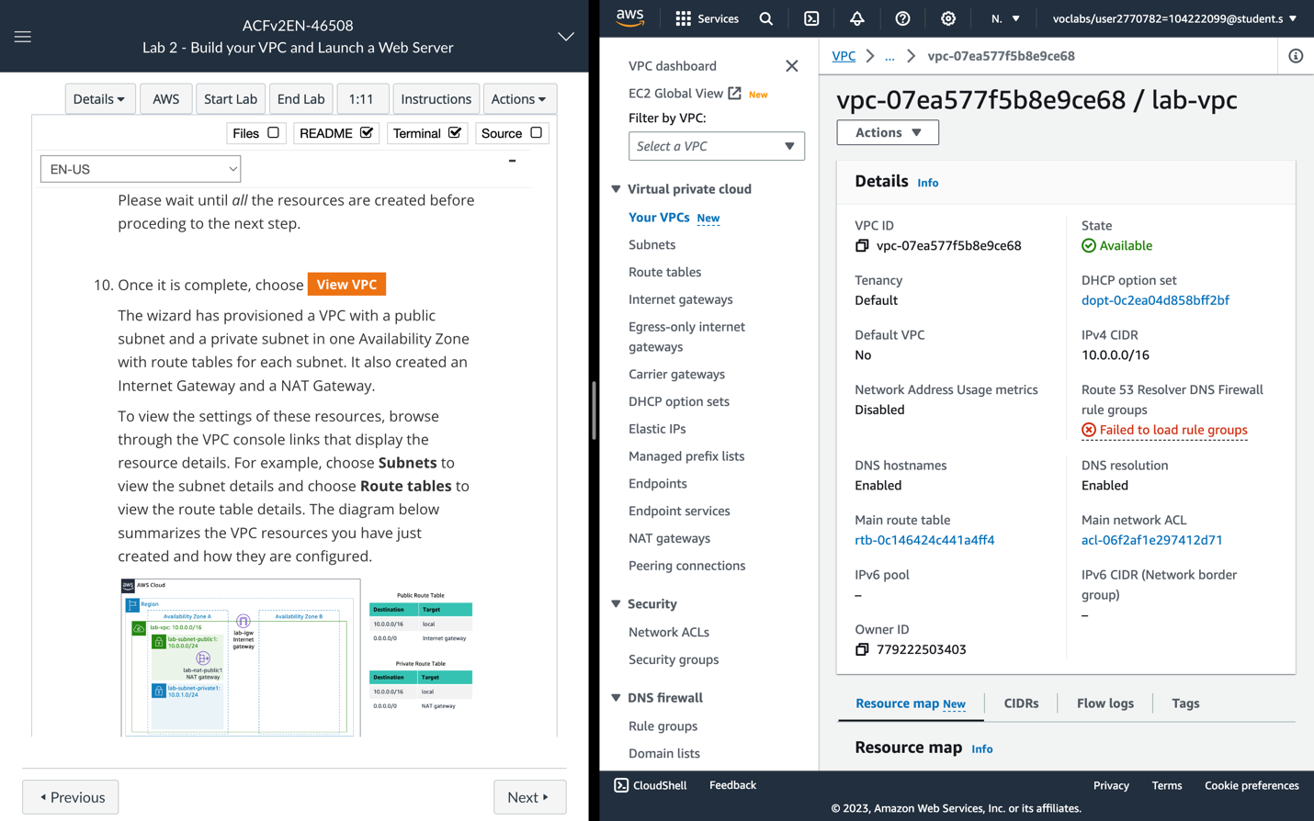

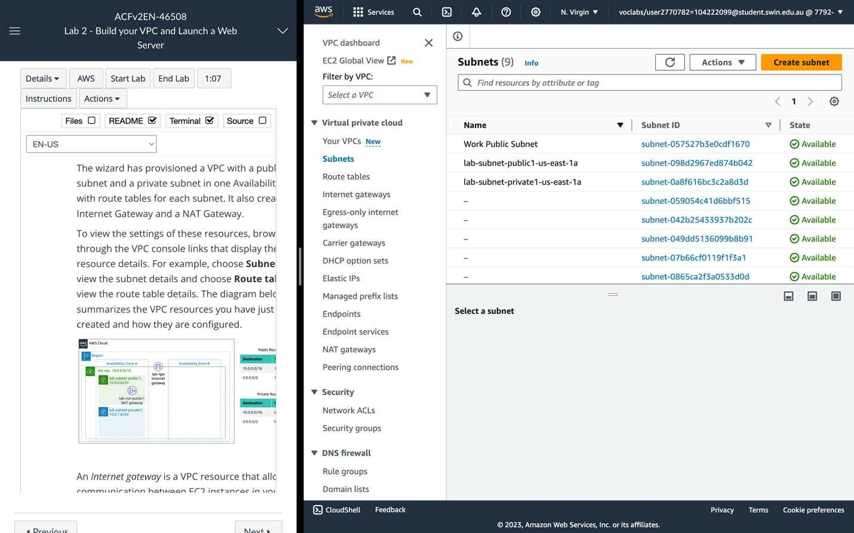

**Subnets** tab

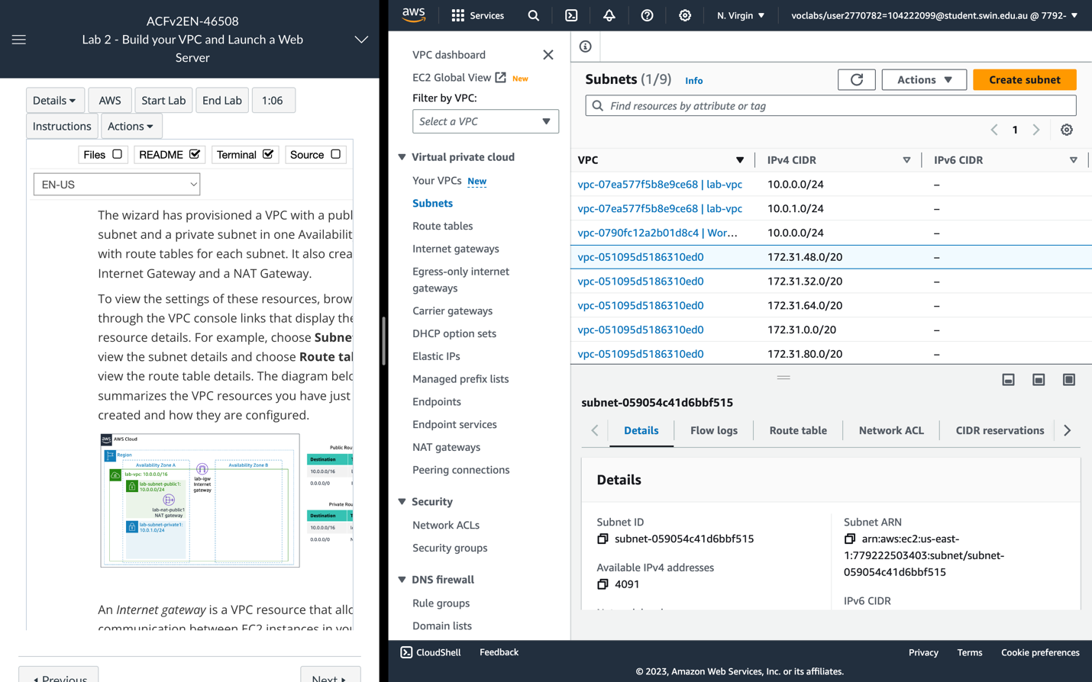

**Subnets** tab

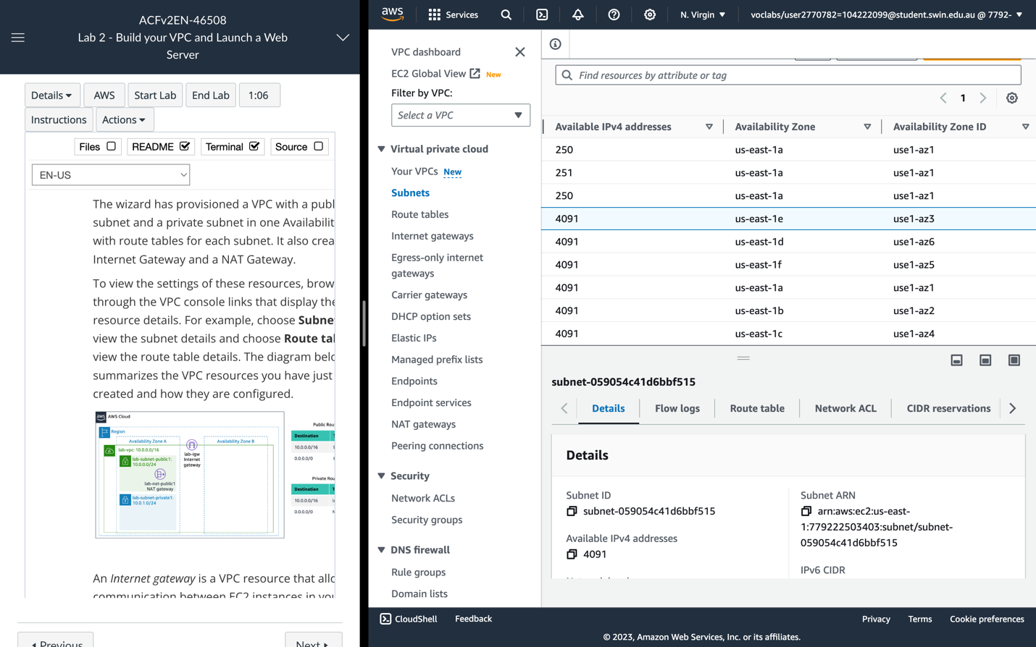

**Subnets** tab

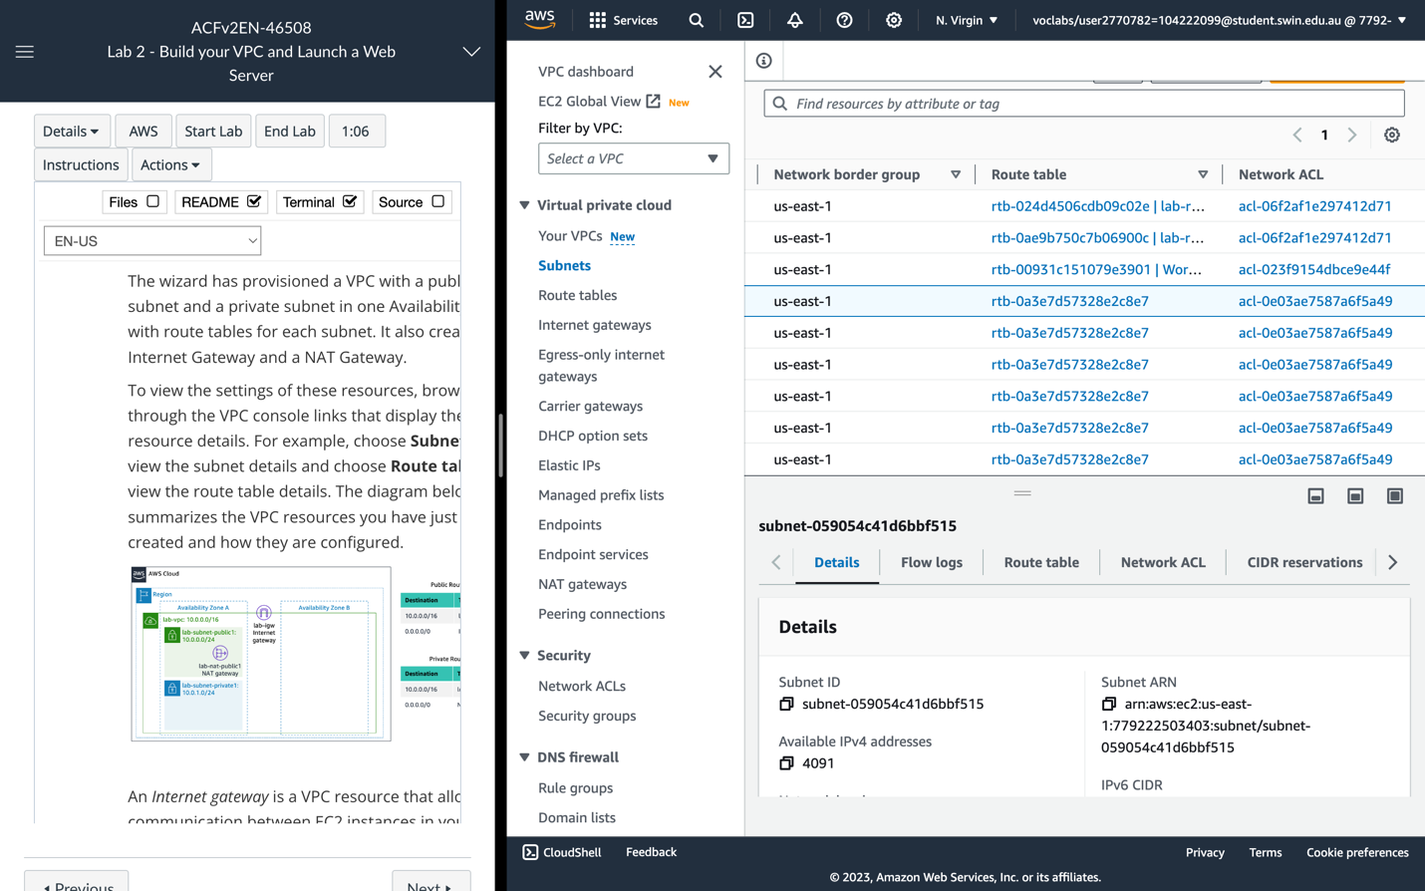

**Subnets** tab

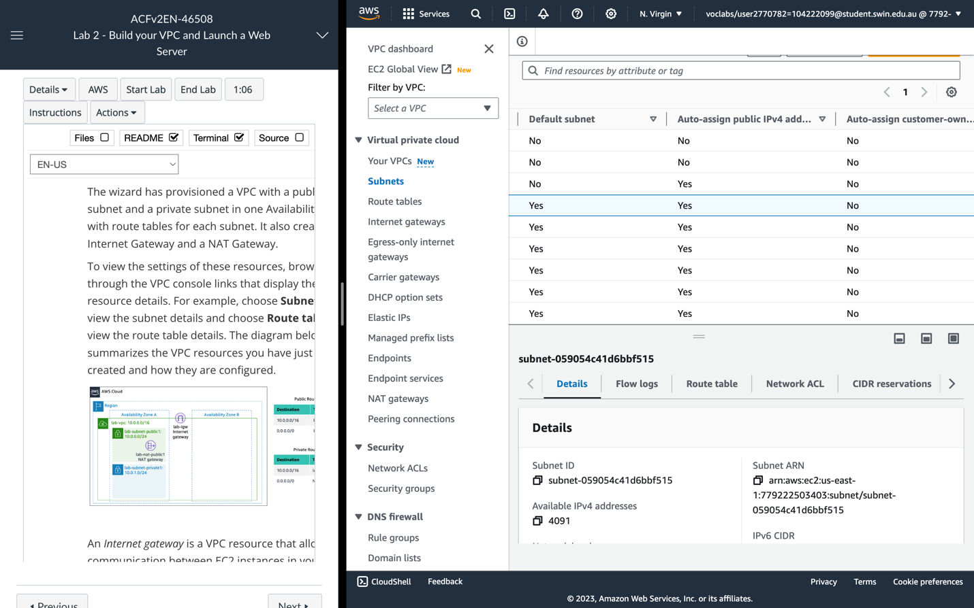

**Subnets** tab

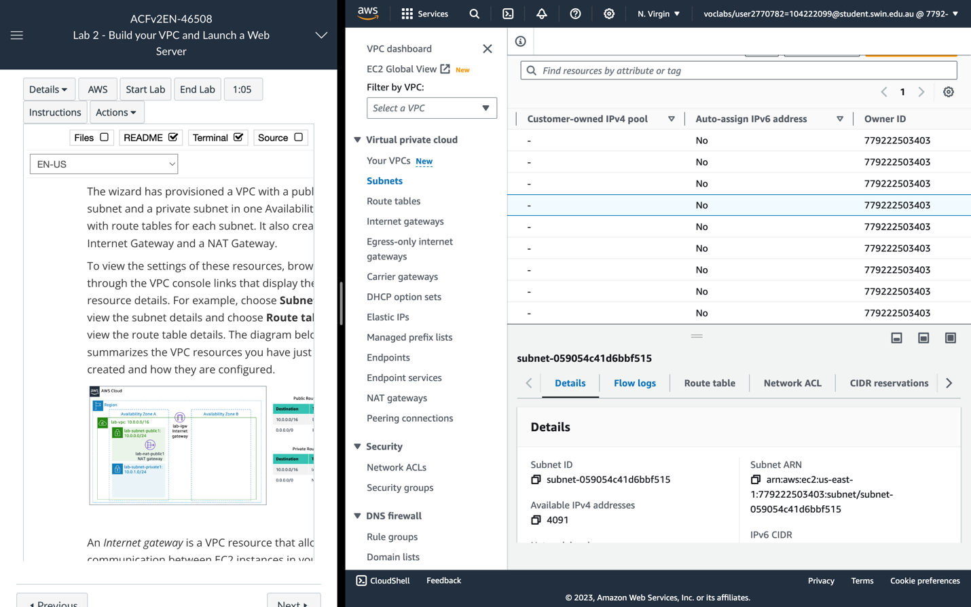

**Subnets** tab

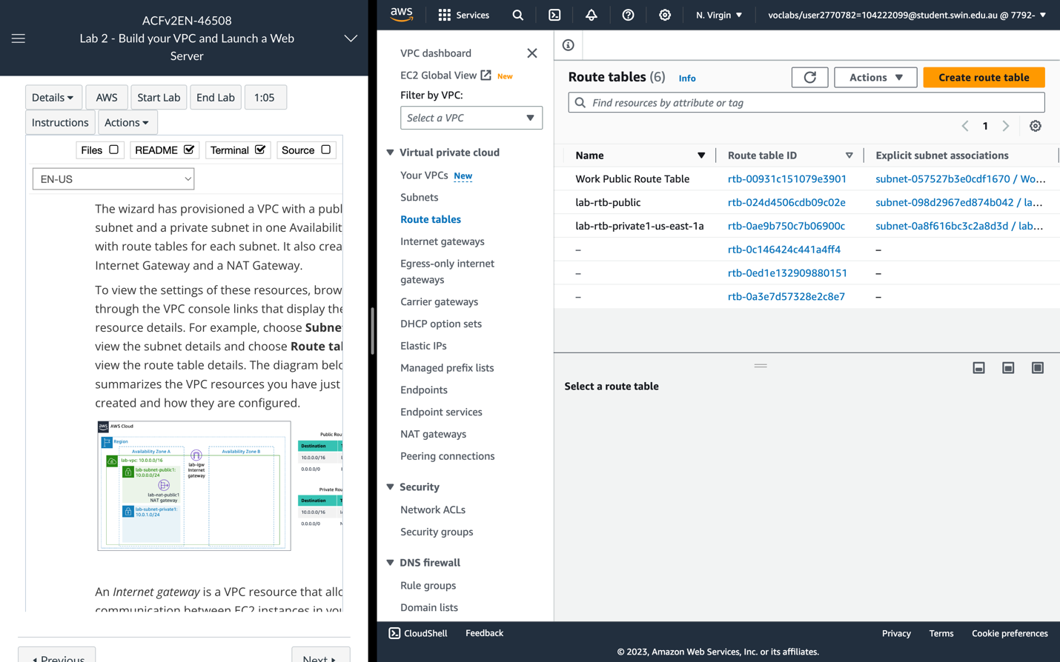

**Route tables** tab

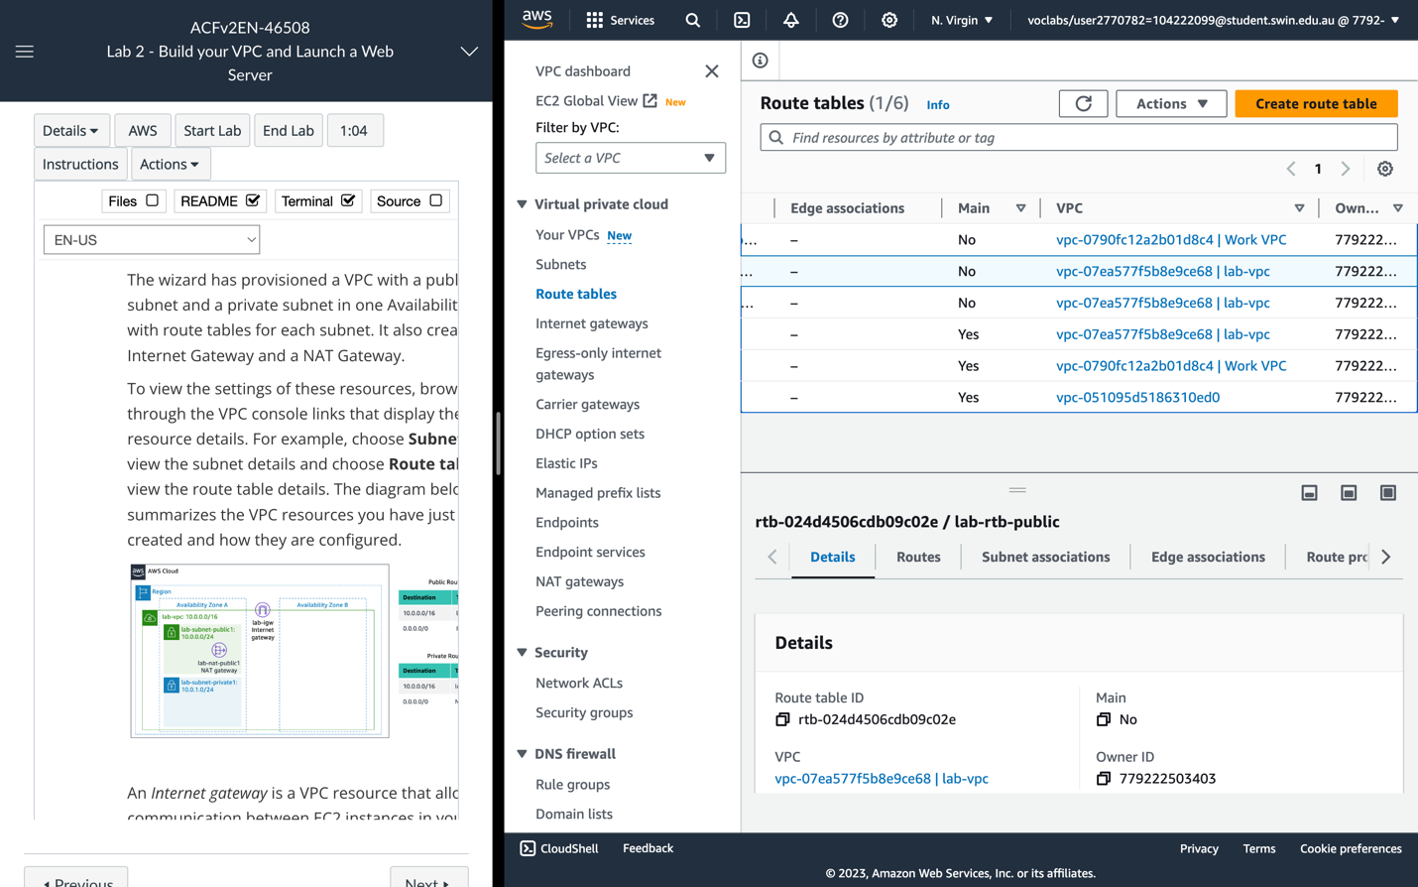

**Route tables** tab

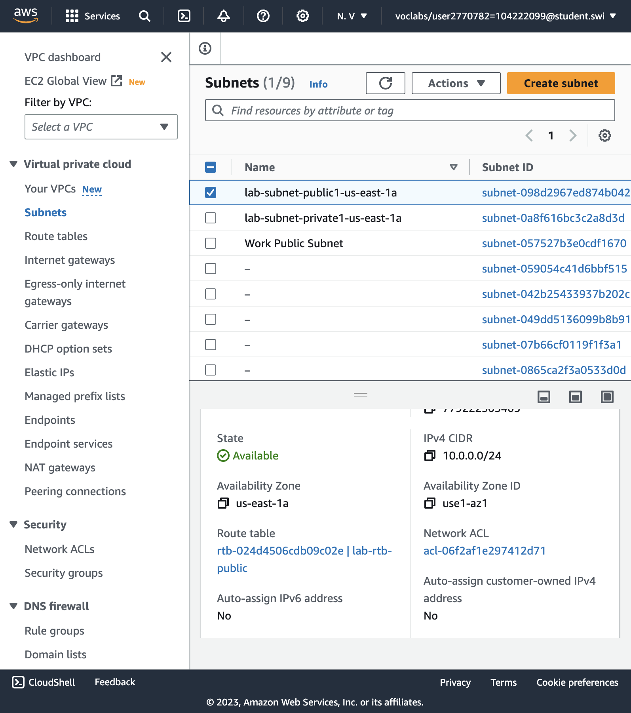

The lab-subnet-public1-us-east-1a public subnet has a CIDR of 10.0.0.0/24, which means that it contains all IP addresses starting with 10.0.0.x. The fact the route table associated with this public subnet routes 0.0.0.0/0 network traffic to the internet gateway is what makes it a public subnet.

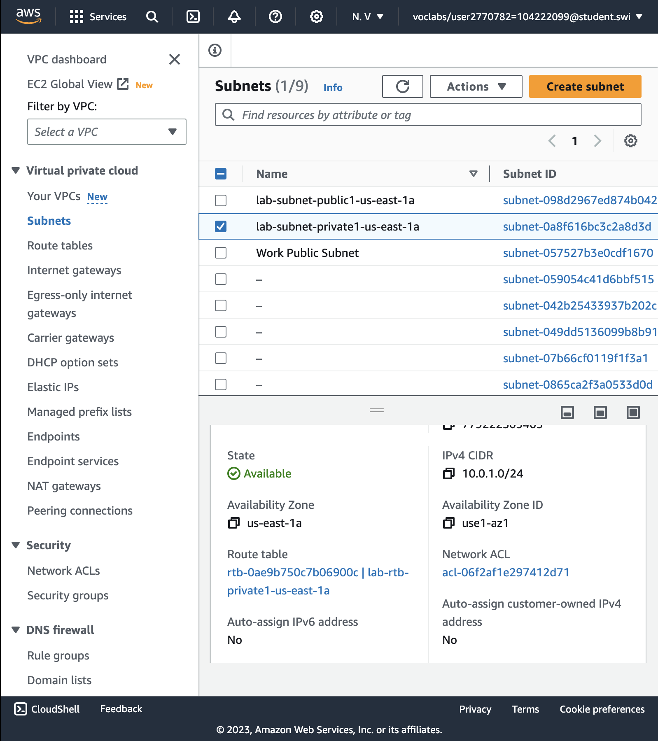

The lab-subnet-private1-us-east-1a private subnet has a CIDR of 10.0.1.0/24, which means that it contains all IP addresses starting with 10.0.1.x.

**TASK 2: CREATE ADDITIONAL SUBNETS**

12. Create a **second subnet.**

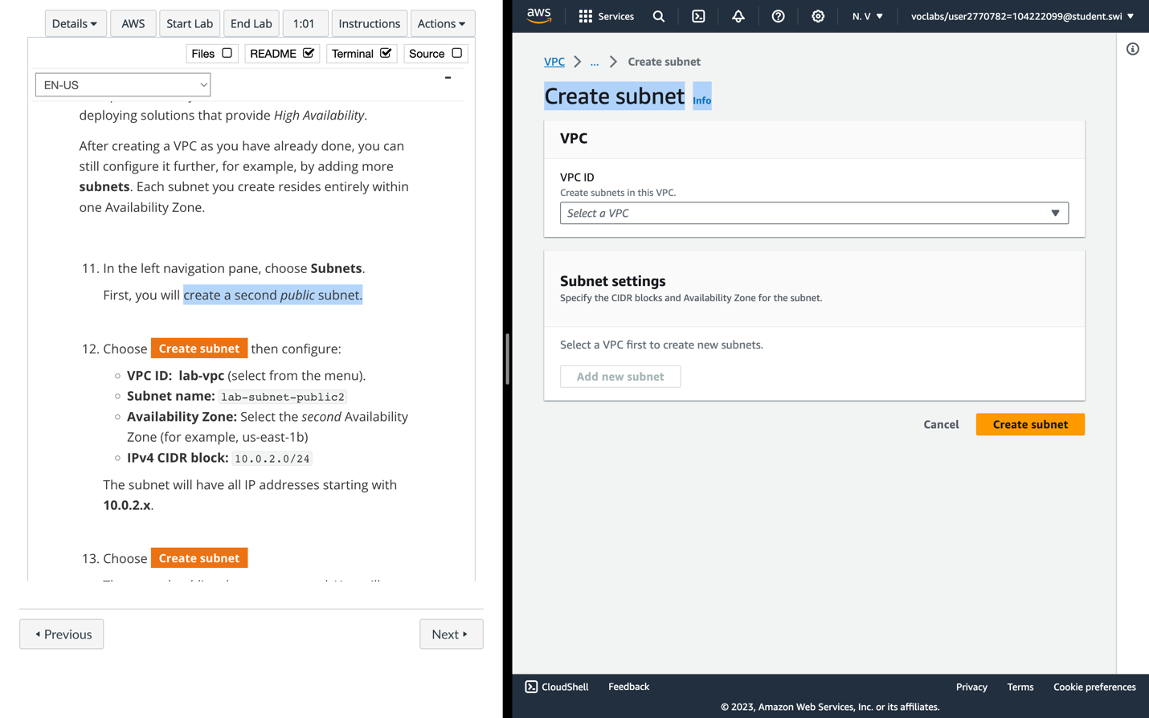

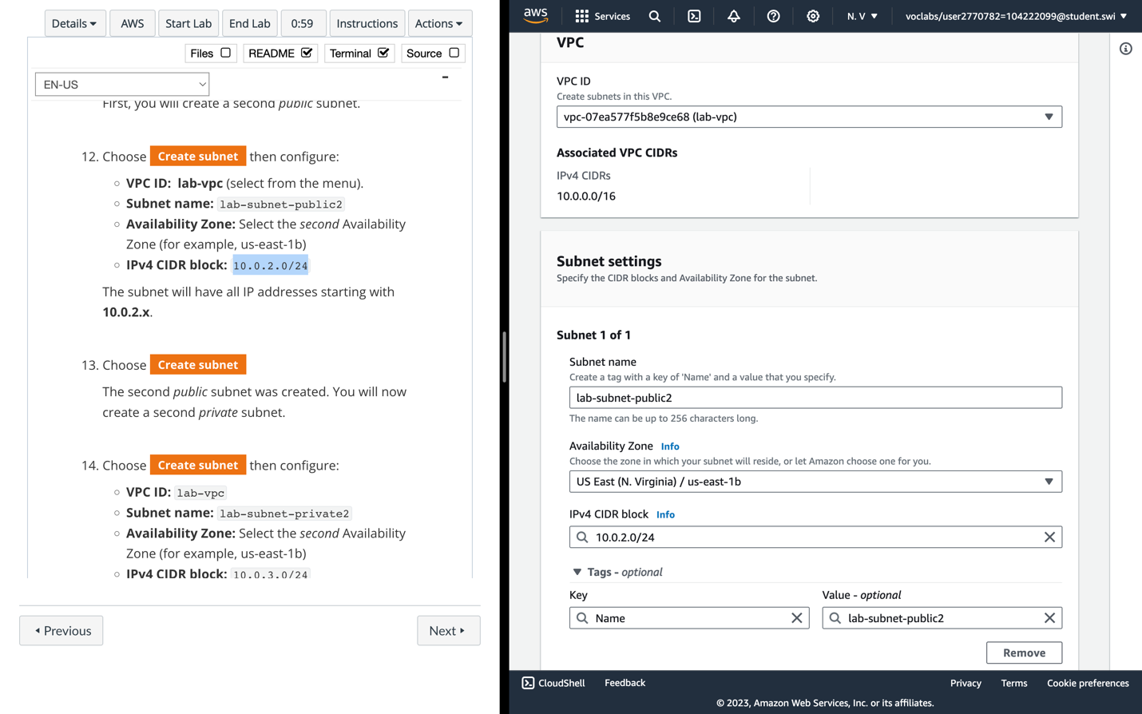

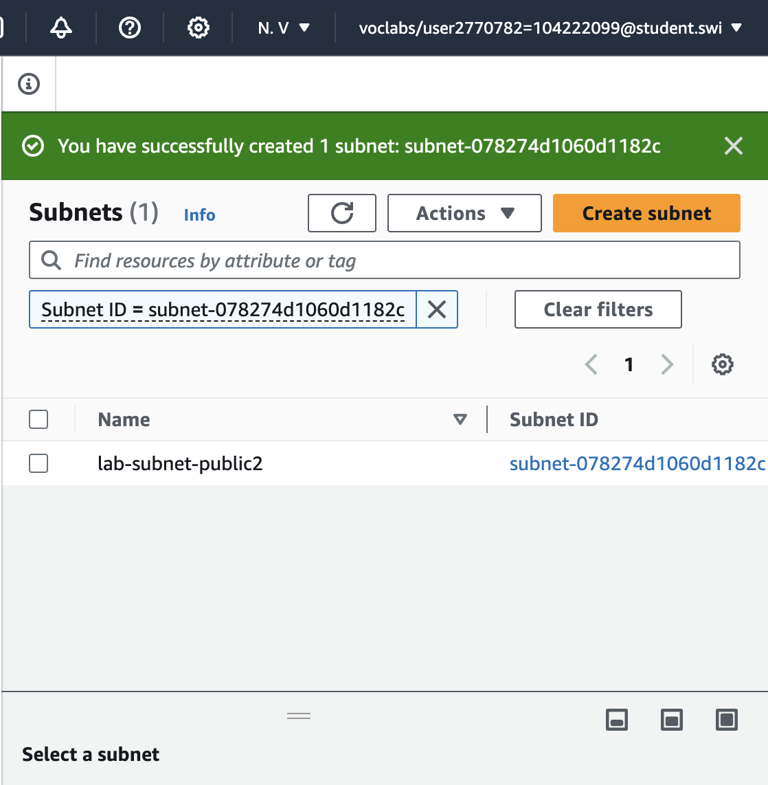

The **second public subnet** was created (*lab-subnet-public2*). The subnet will have all IP addresses starting with **10.0.2.x**.

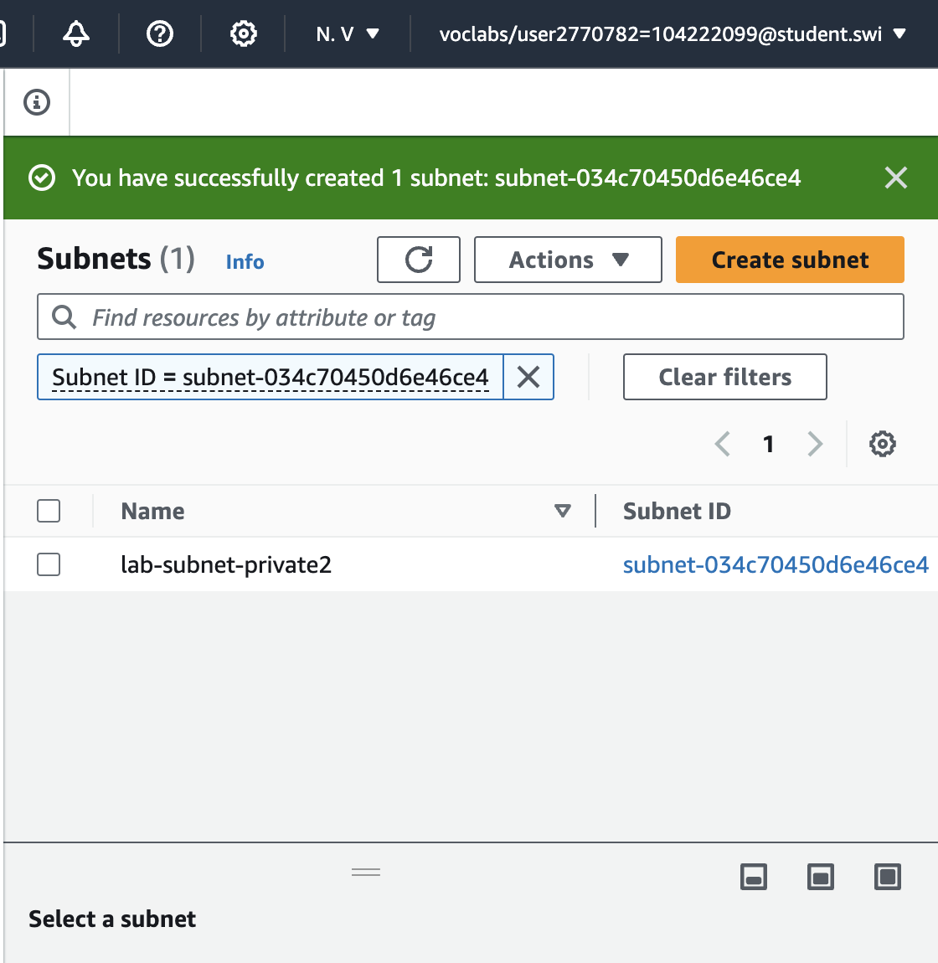

The **second private subnet** was created (*lab-subnet-private2*). The subnet will have all IP addresses starting with **10.0.3.x**.

16. Choose “Route tables”

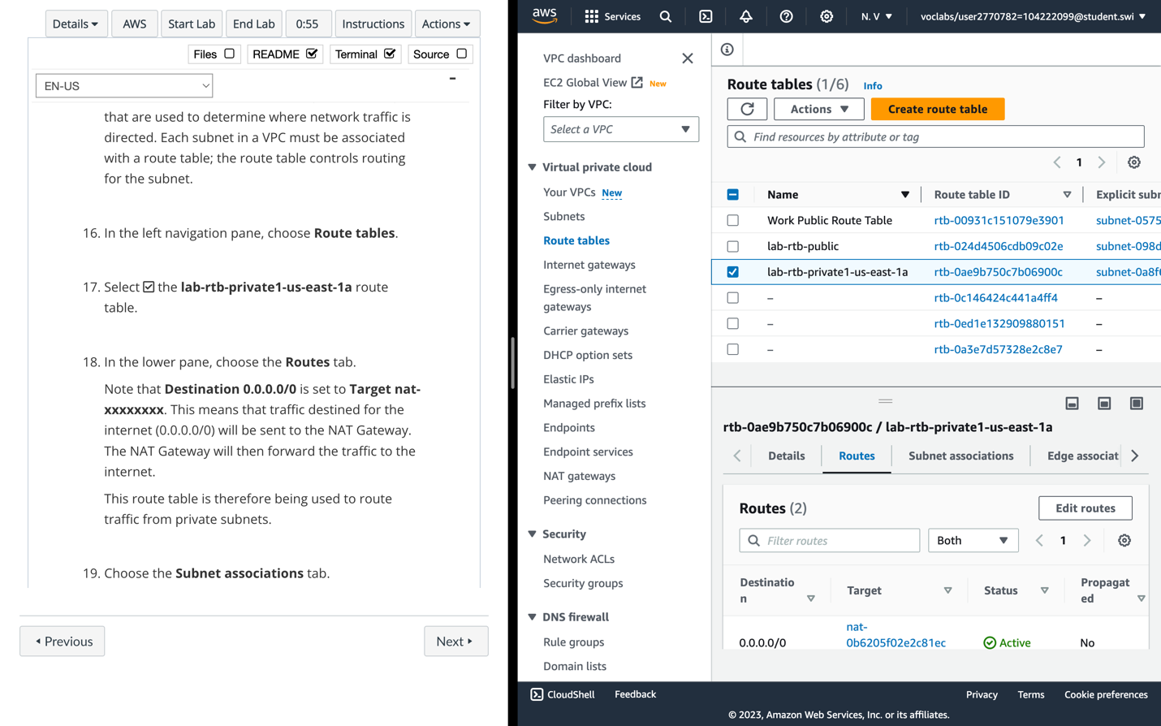

18. Note that Destination ***0.0.0.0/0*** is set to Target ***nat-xxxxxxxx***. This means that traffic destined for the internet (0.0.0.0/0) will be sent to the **NAT Gateway**. The NAT Gateway will then forward the traffic to the internet.

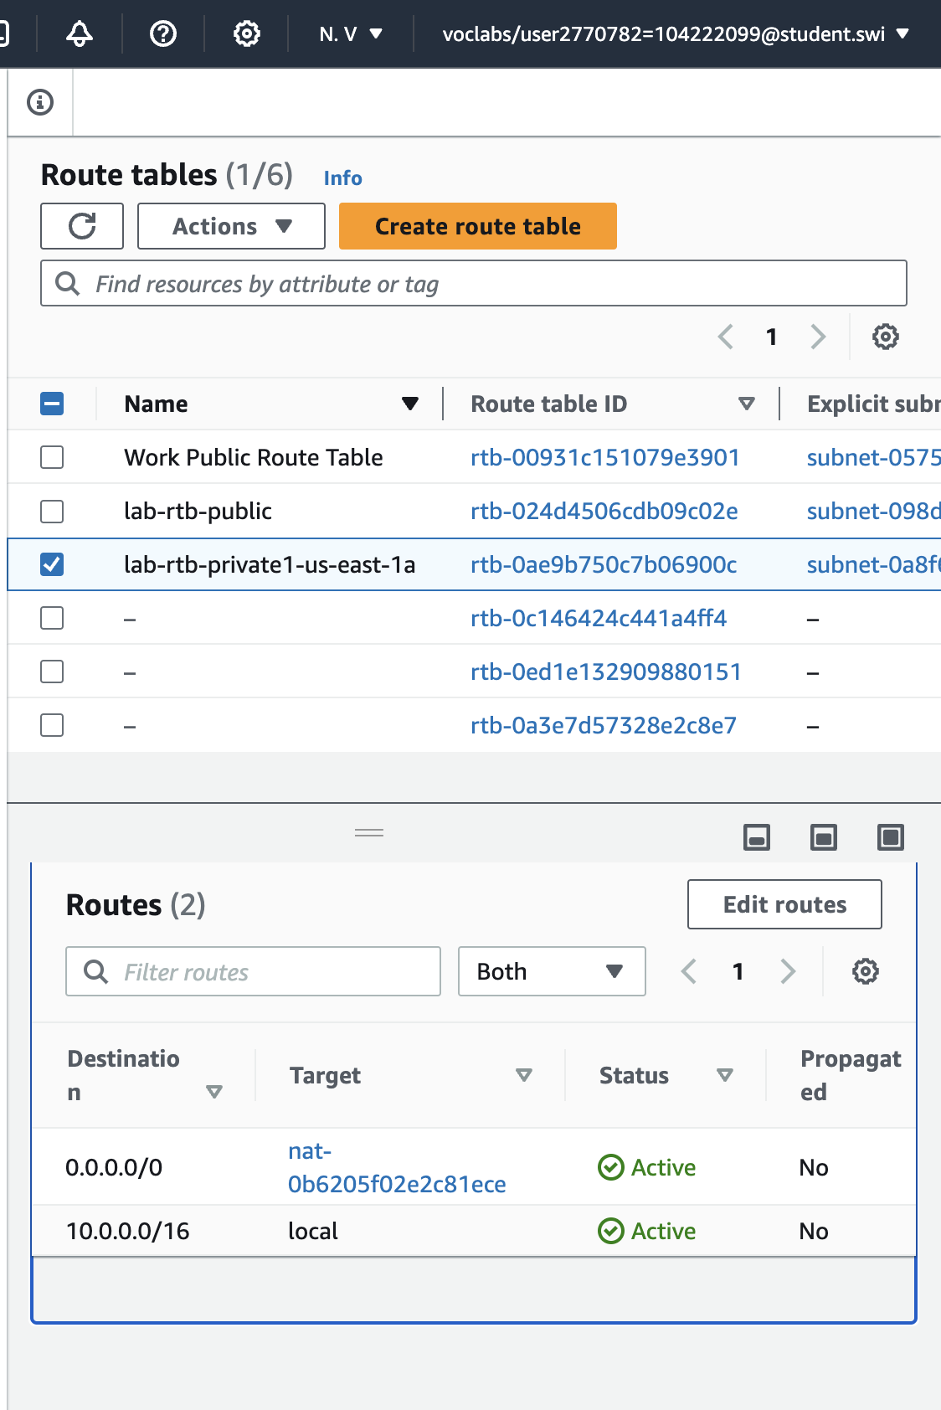

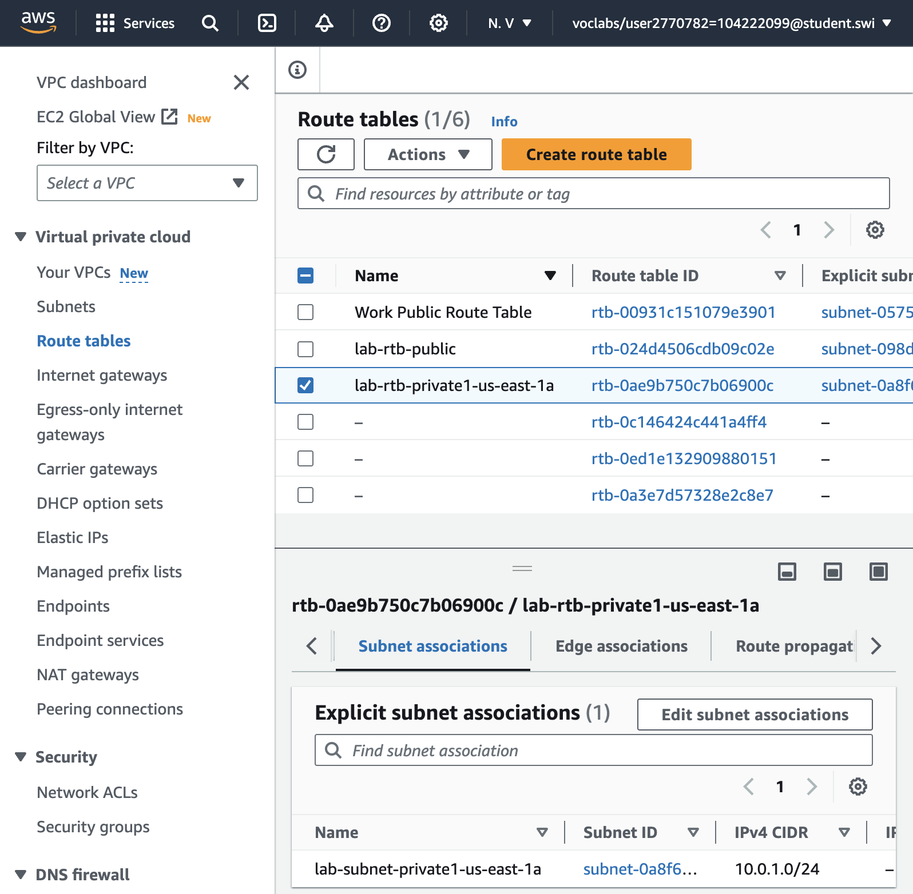

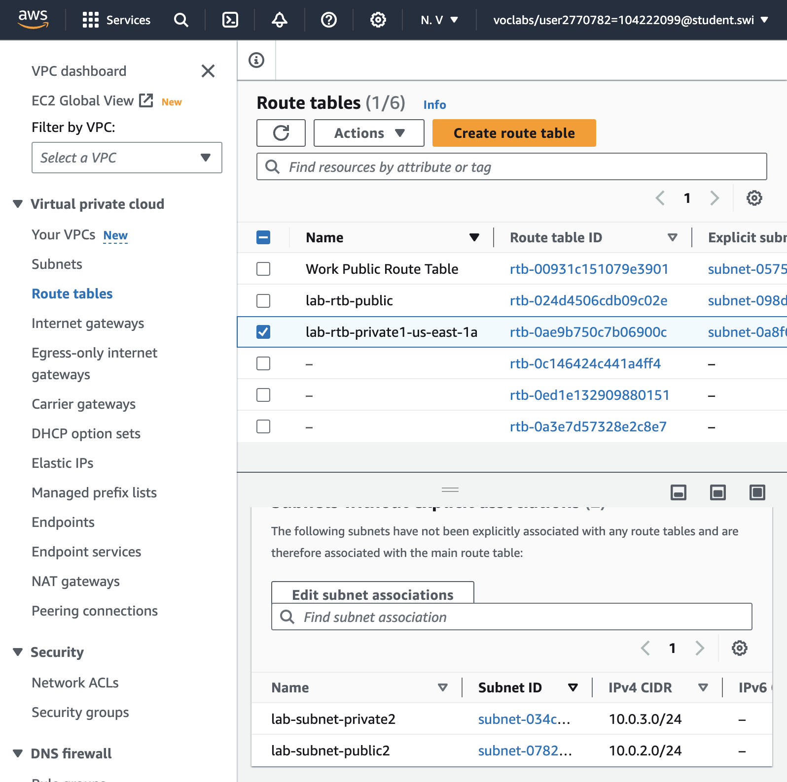

20. Edit subnet associations

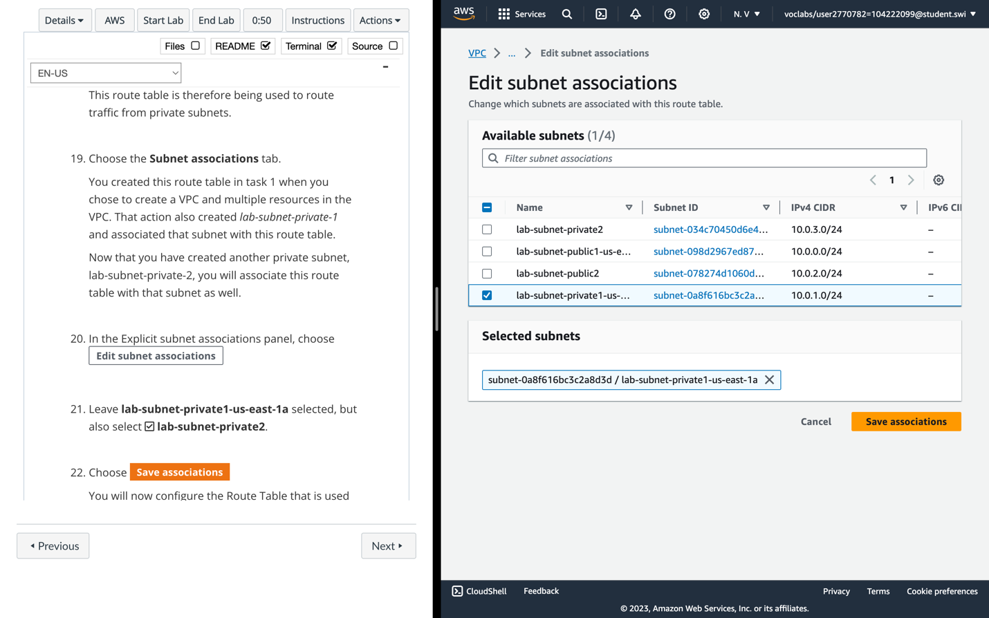

21. Leave ***lab-subnet-private1-us-east-1a*** selected, but also select ***lab-subnet-private2***.

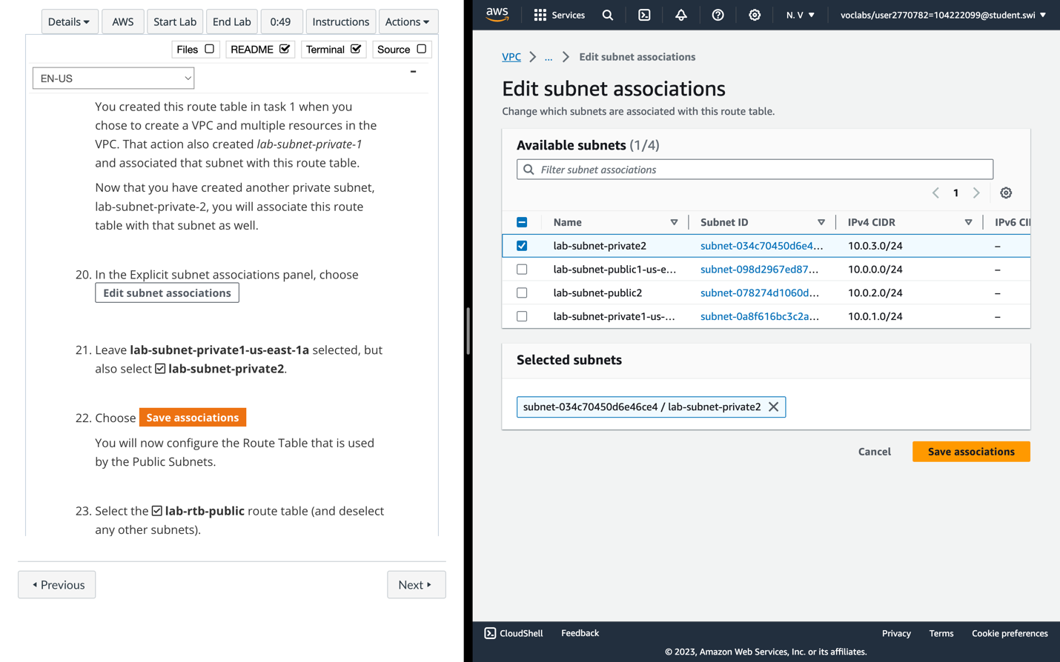

23. Select the ***lab-rtb-public*** route table (and deselect any other subnets).

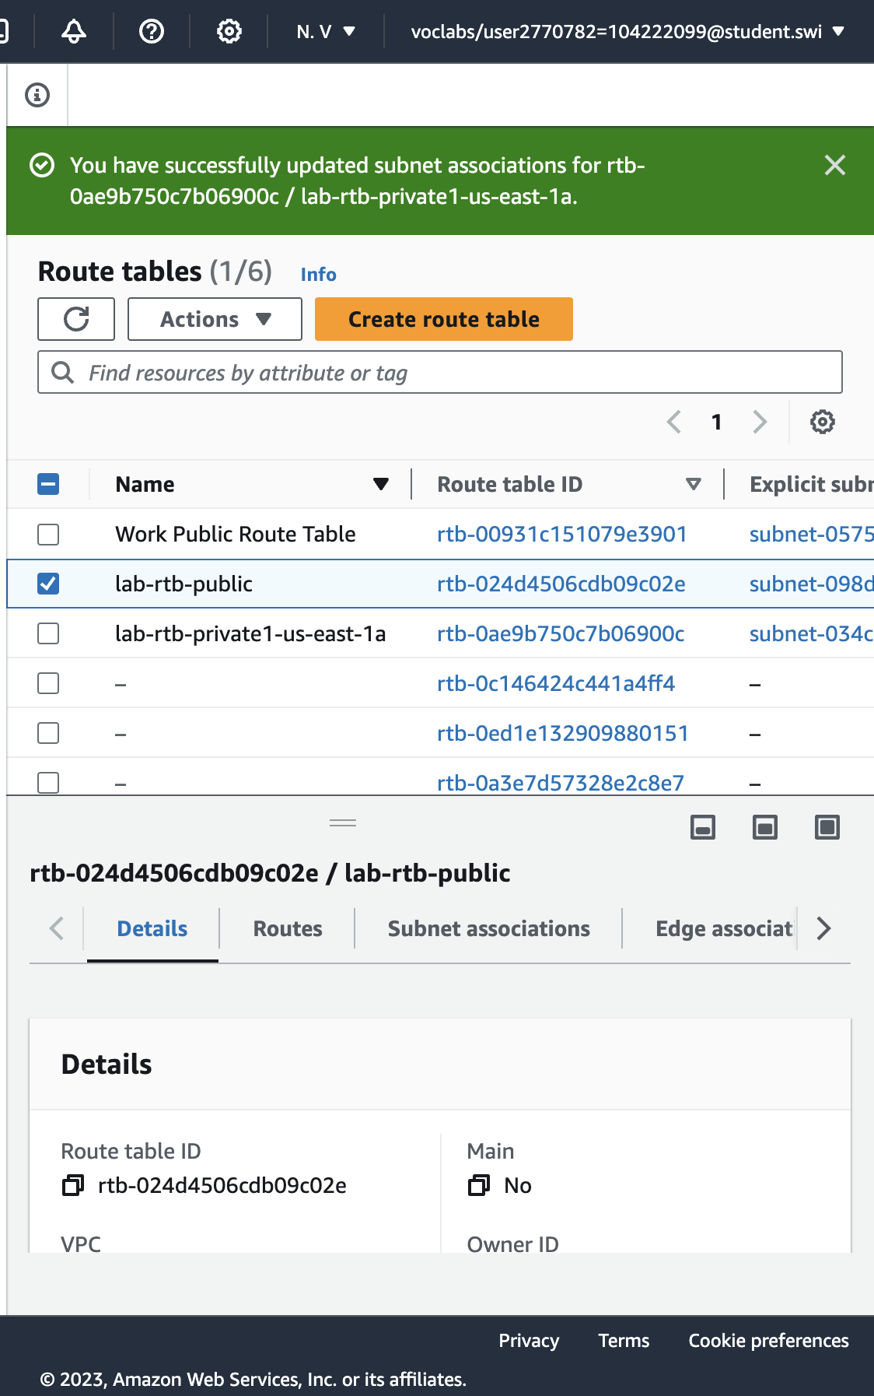

24. Note that Destination ***0.0.0.0/0*** is set to Target ***igw-xxxxxxxx***, which is an **Internet Gateway**. This means that internet-bound traffic will be sent straight to the internet via this Internet Gateway.

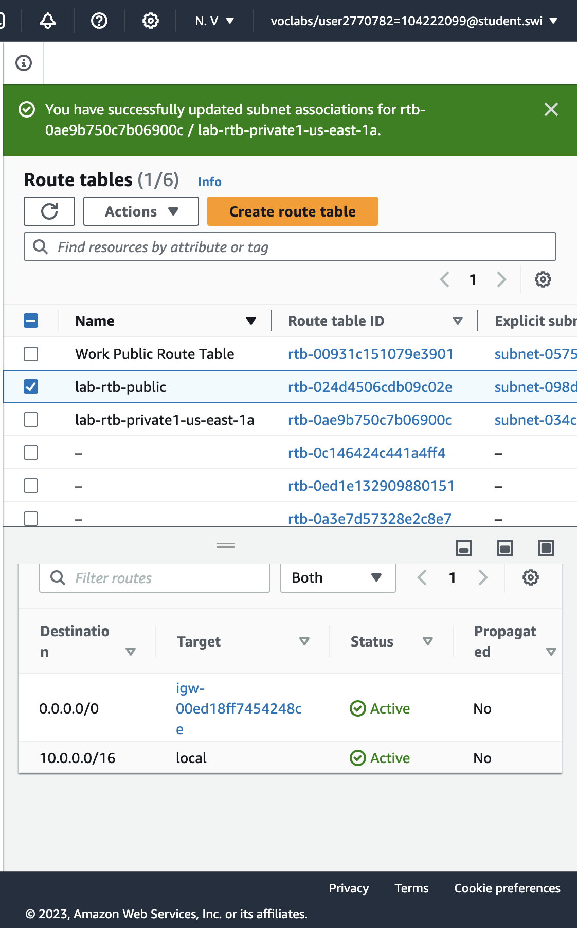

27. Leave **lab-subnet-public1-us-east-1a** selected, but also select **lab-subnet-public2**.

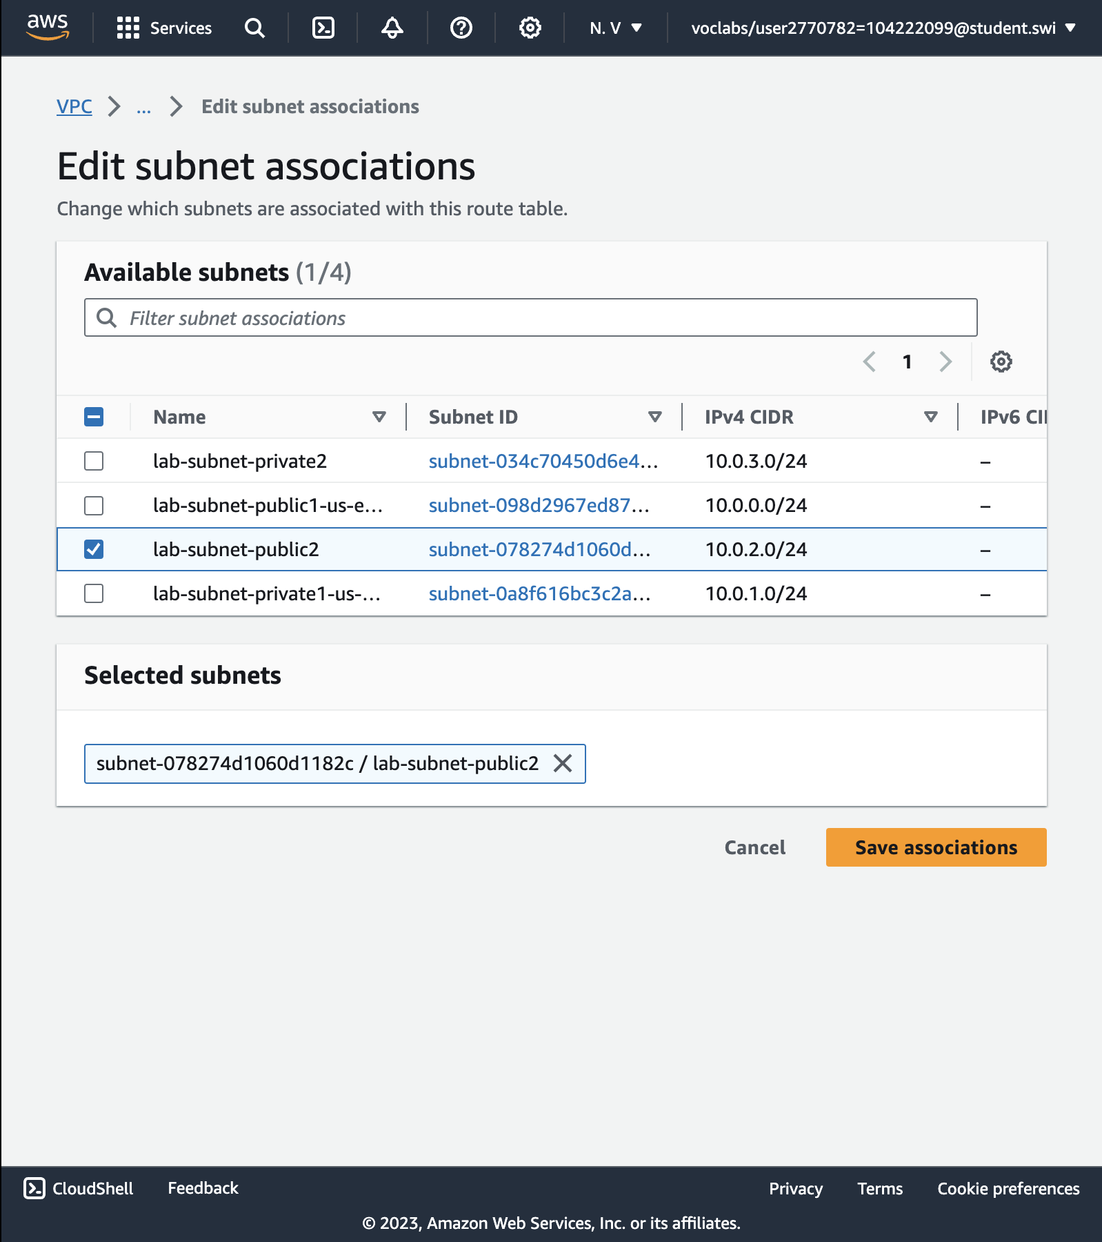

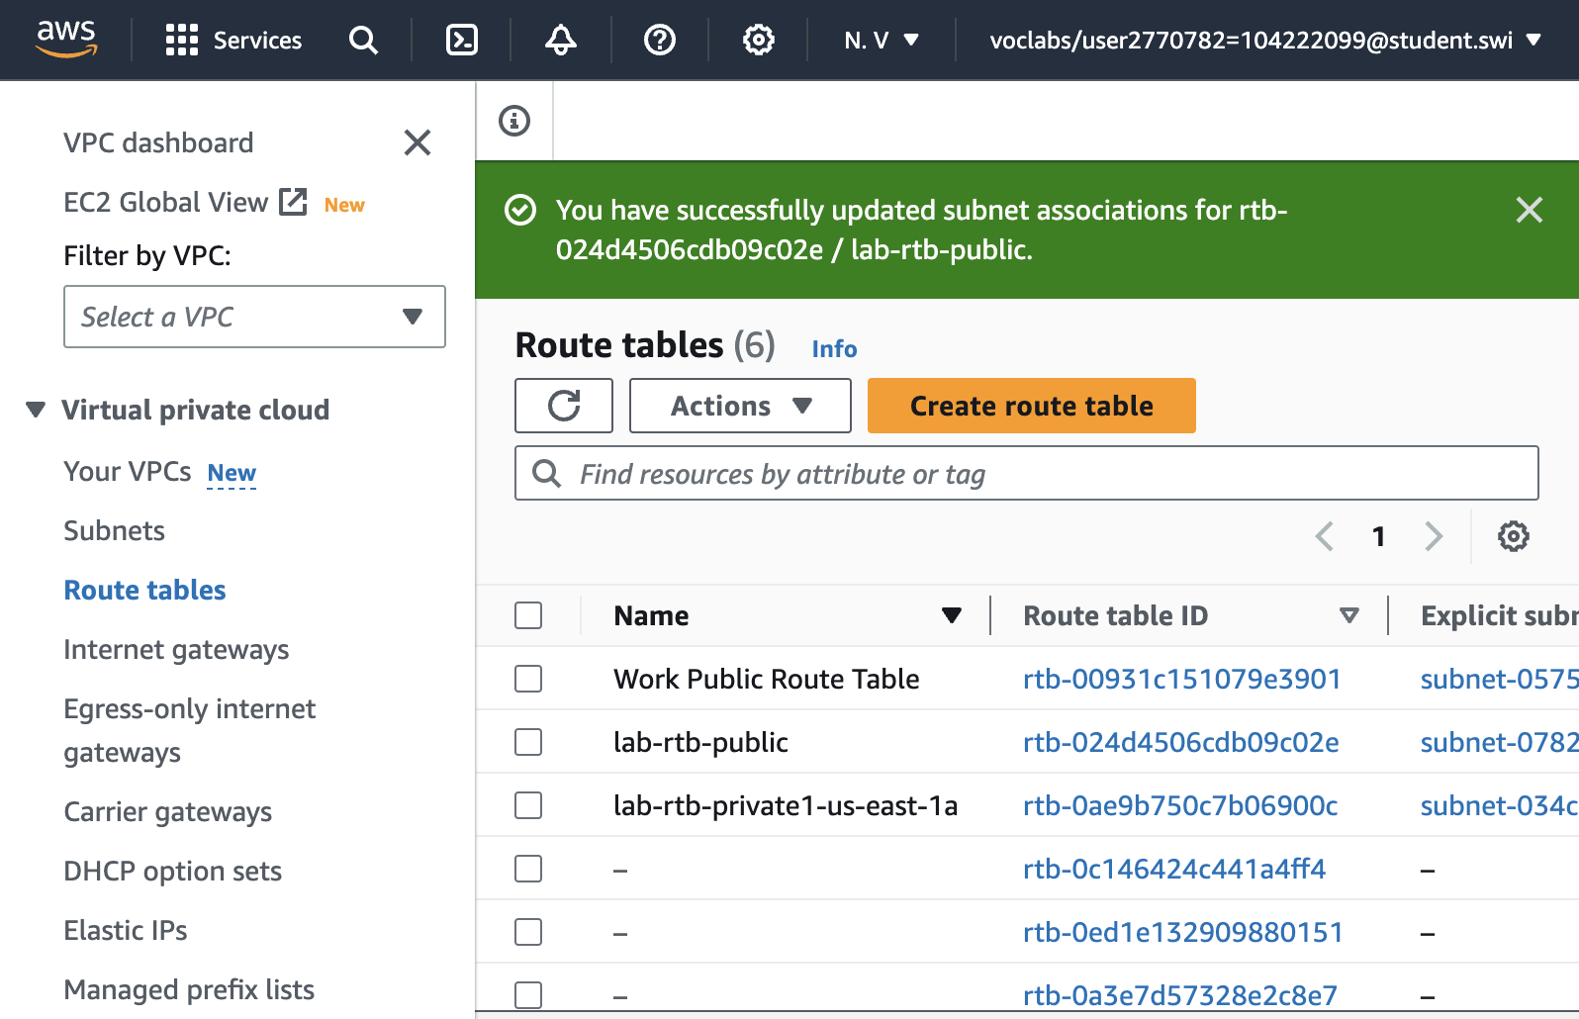

Successfully updated subnet associations for ***lab-rtb-public***

**TASK 3: CREATE A VPC SECURITY GROUP**

29. Create security groups.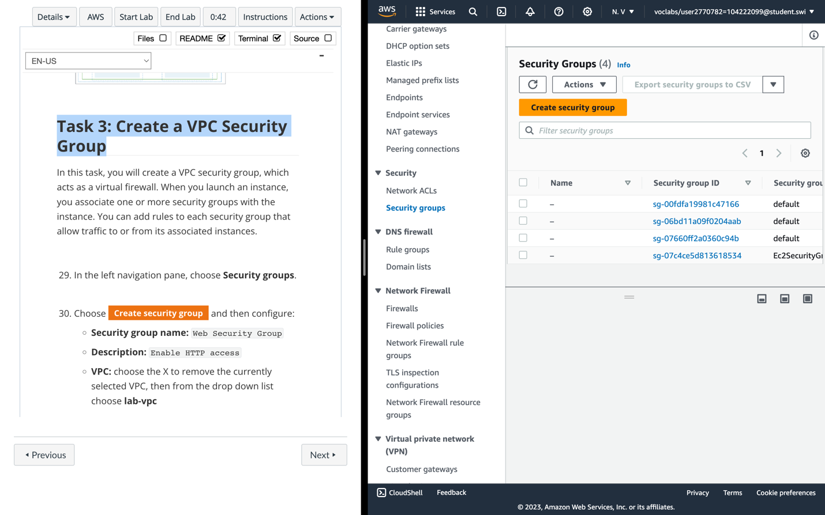

30. Configure the **Security group**.

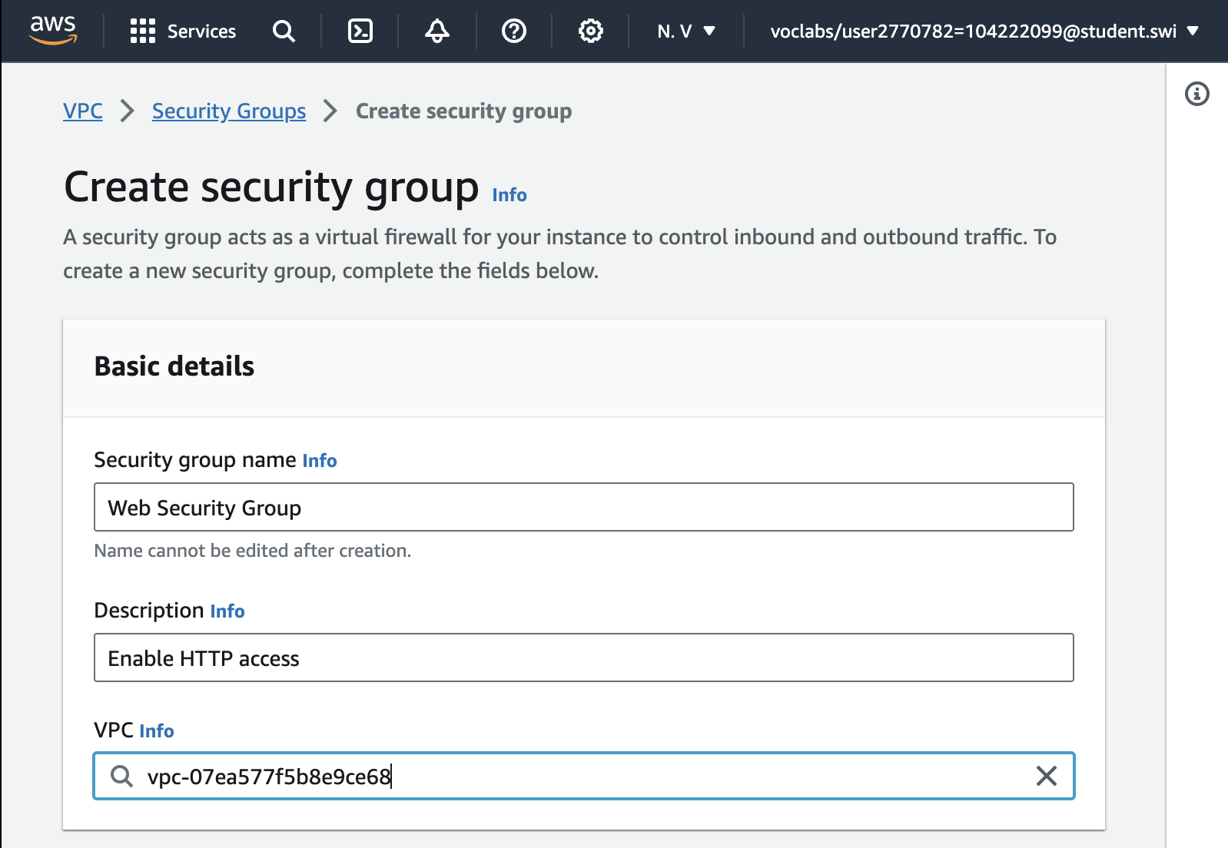

* **Security group name:** Web Security Group
* **Description:** Enable HTTP access
* **VPC:** choose the X to remove the currently selected VPC, then from the drop down list choose **lab-vpc**

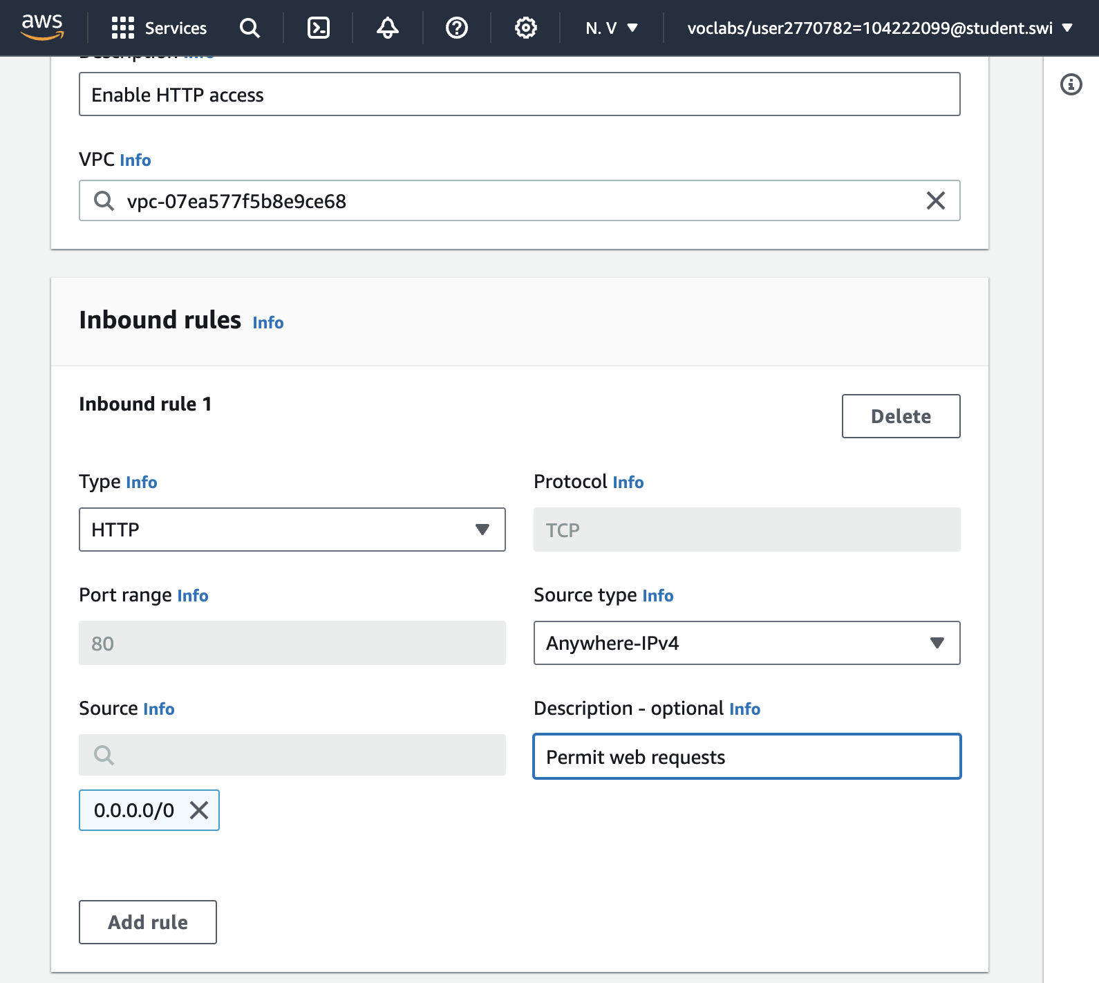

Add **Inbound rule**

* **Type:** *HTTP*
* **Source:** *Anywhere-IPv4*
* **Description:** Permit web requests

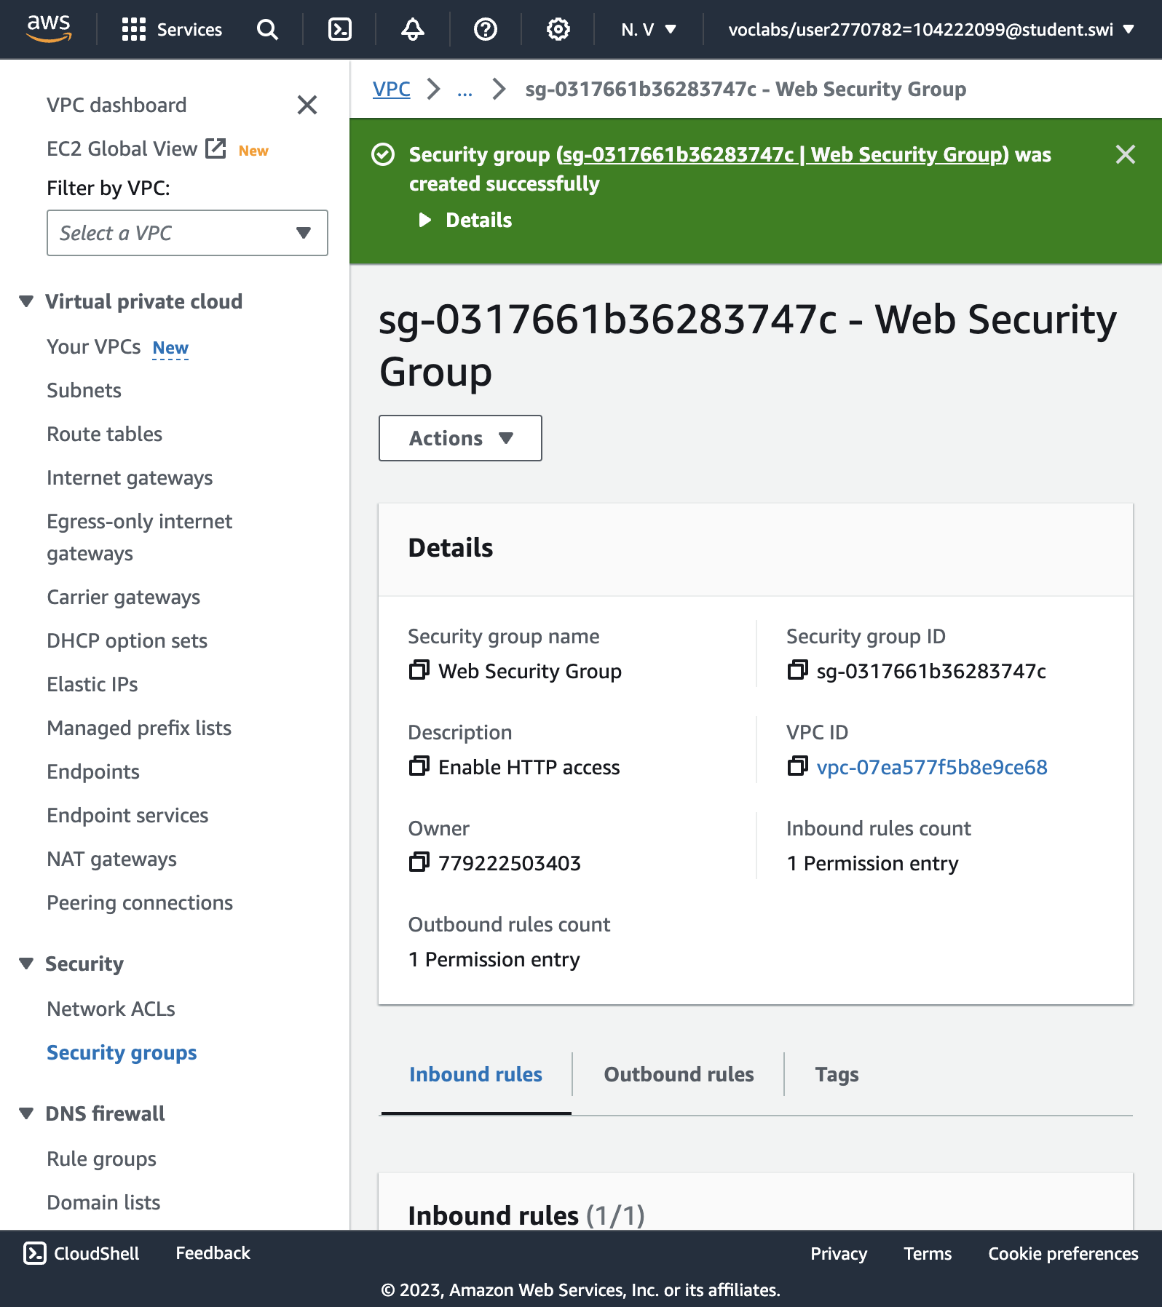

Successfully created security group.

TASK 4: LAUNCH A WEB SERVER INSTANCE

34. Search for and choose **EC2** to open the **EC2 console**.

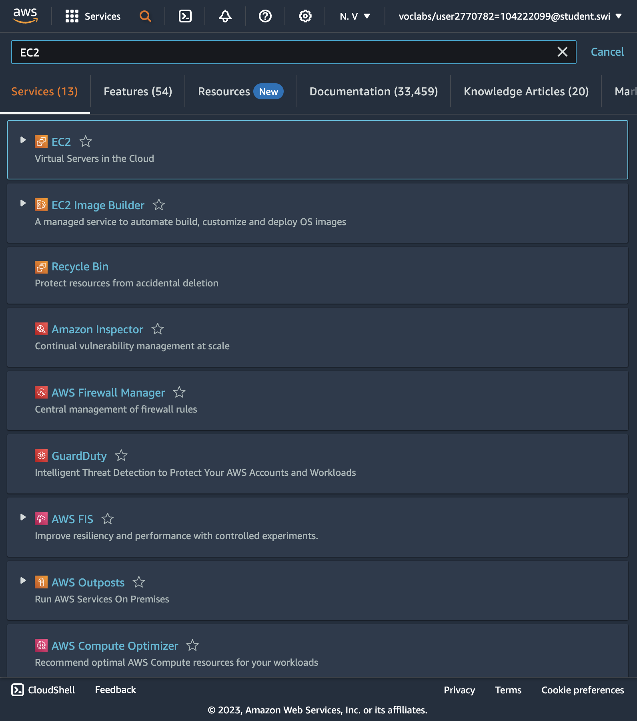

36. Name the instance.

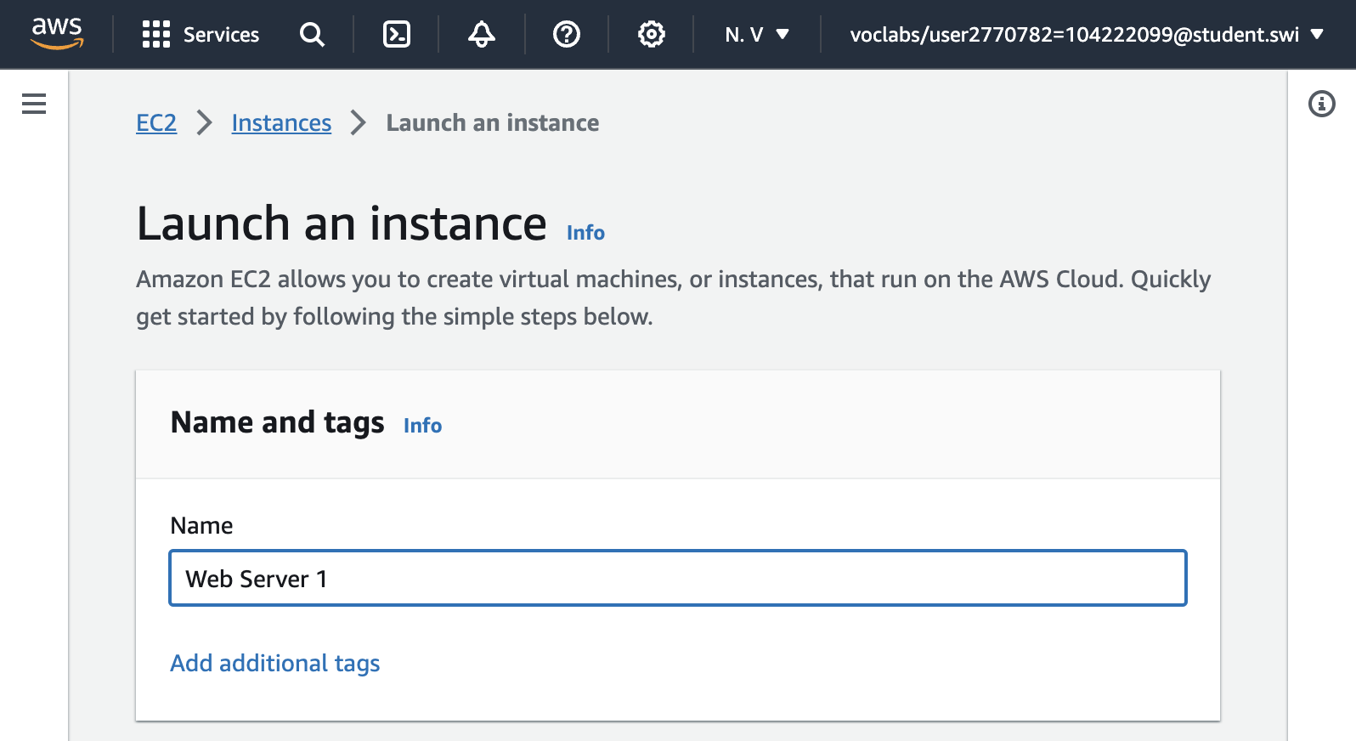

Name: ***Web server 1***

37. Choose an AMI from which to create the instance.

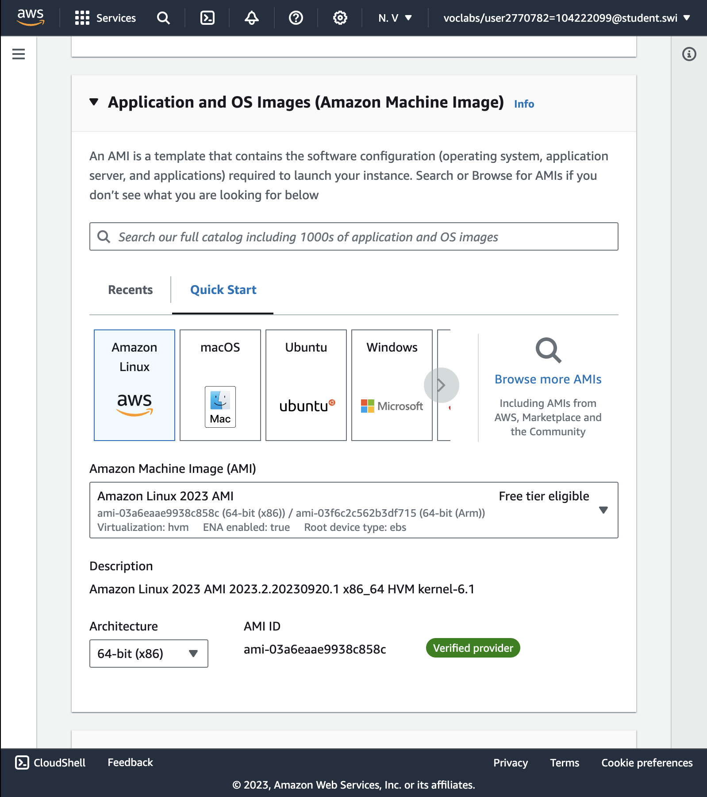

Amazone Linux

38. Instance type.

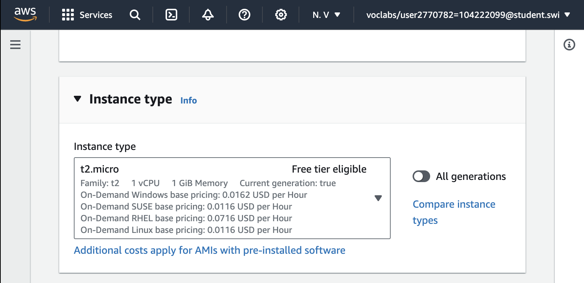

t2.micro

39. Key pair.

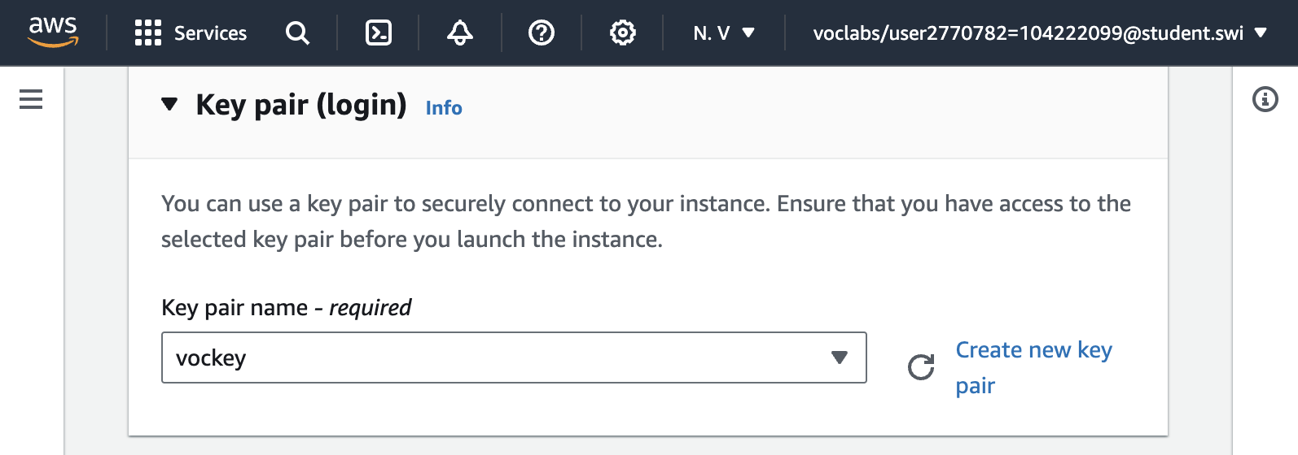

vockey

40. Network setting.

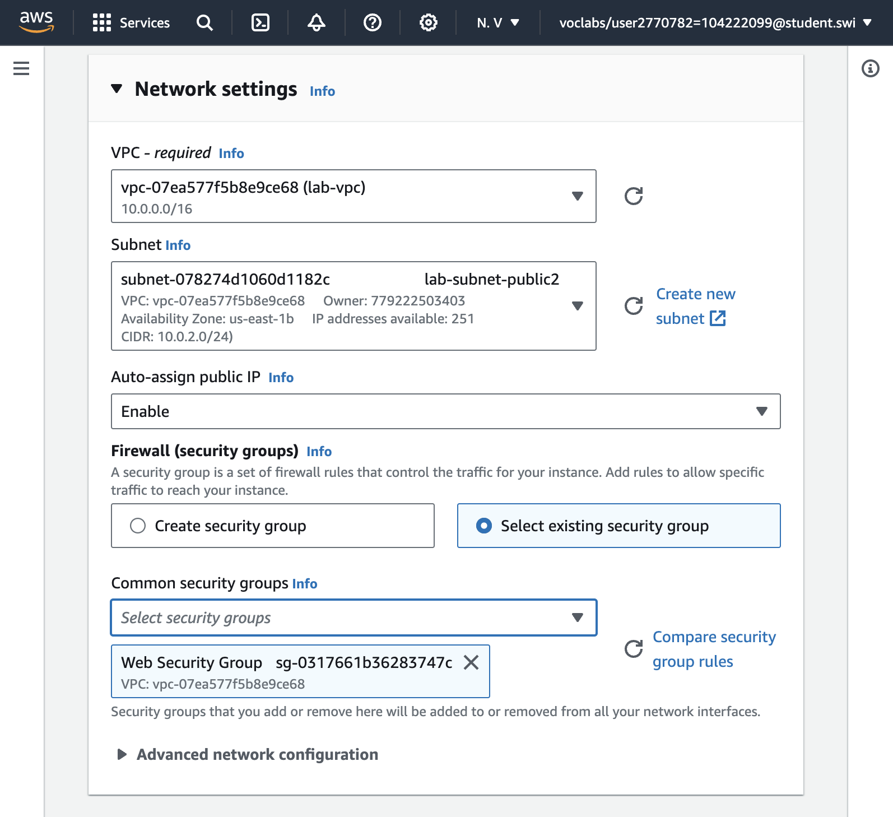

* + **Network:** *lab-vpc*
  + **Subnet:** *lab-subnet-public2* (*not* Private!)
  + **Auto-assign public IP:** *Enable*

Next, you will configure the instance to use the *Web Security Group* that you created earlier.

* + Under Firewall (security groups), choose **Select existing security group**.
  + For **Common security groups**, select **Web Security Group**.

This security group will permit HTTP access to the instance.

41. Configure storage (Keeping default setting)

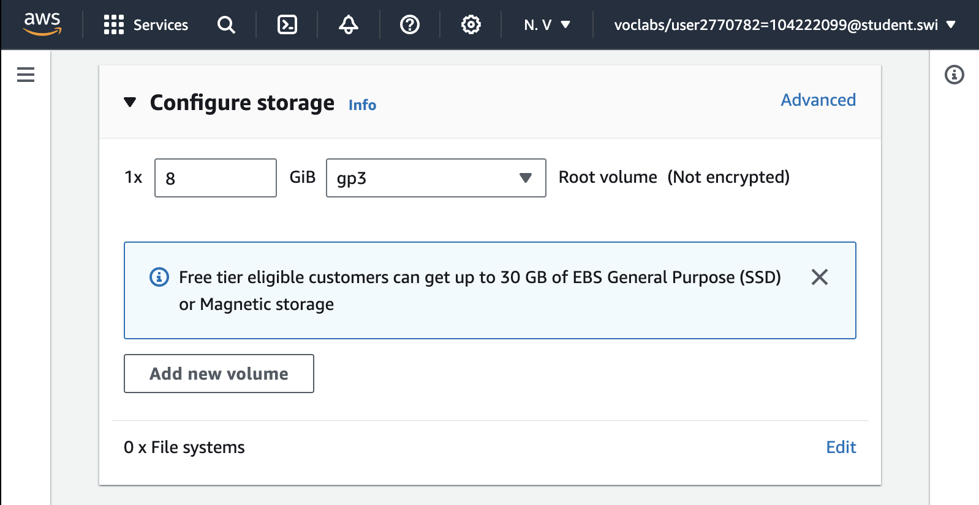

42. Configure a script to run on the instance when it launches.

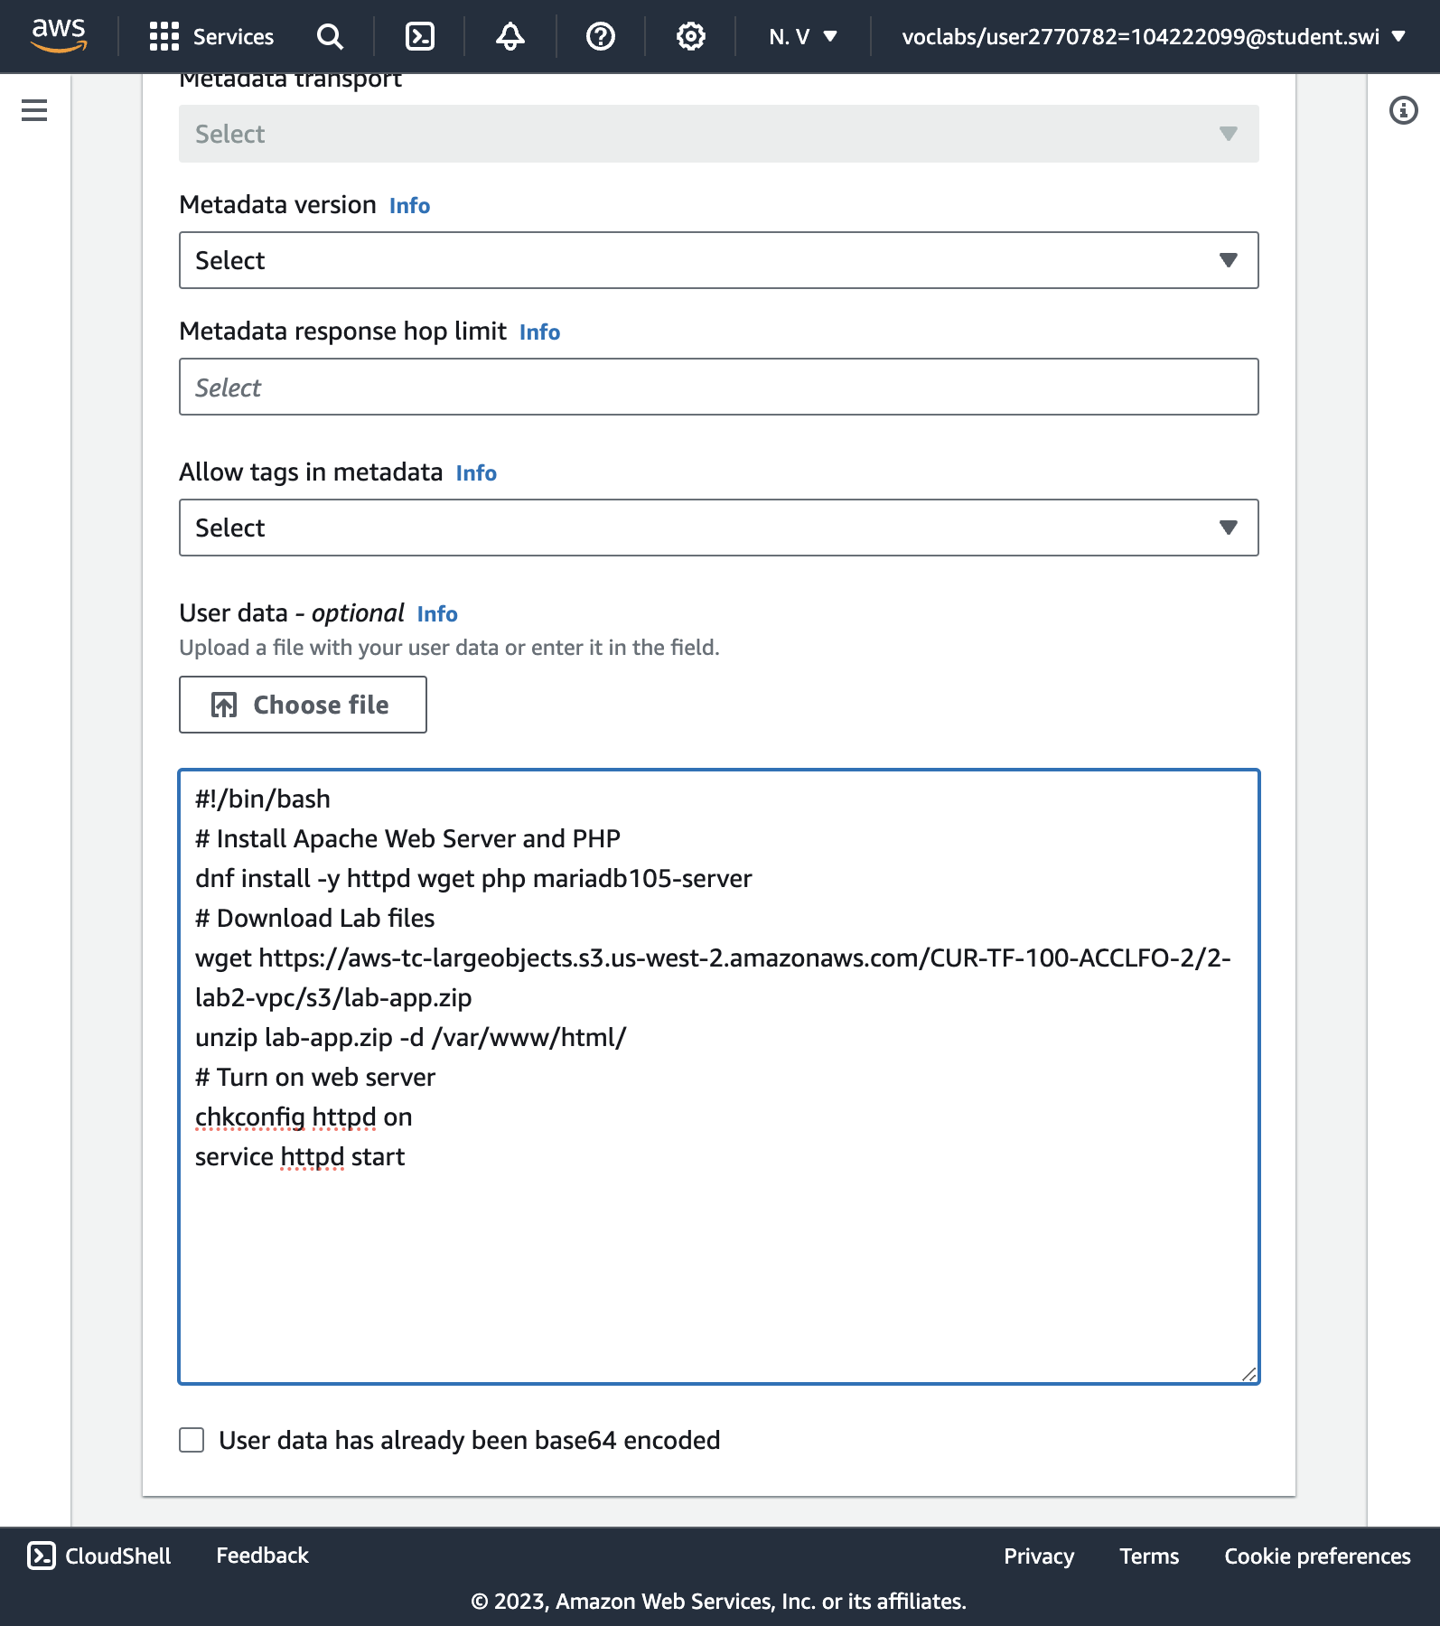

This script will run with root user permissions on the guest OS of the instance. It will run automatically when the instance launches for the first time. The script installs a web server, a database, and PHP libraries, and then it downloads and installs a PHP web application on the web server.

43. Successfully initiated launch of instance.

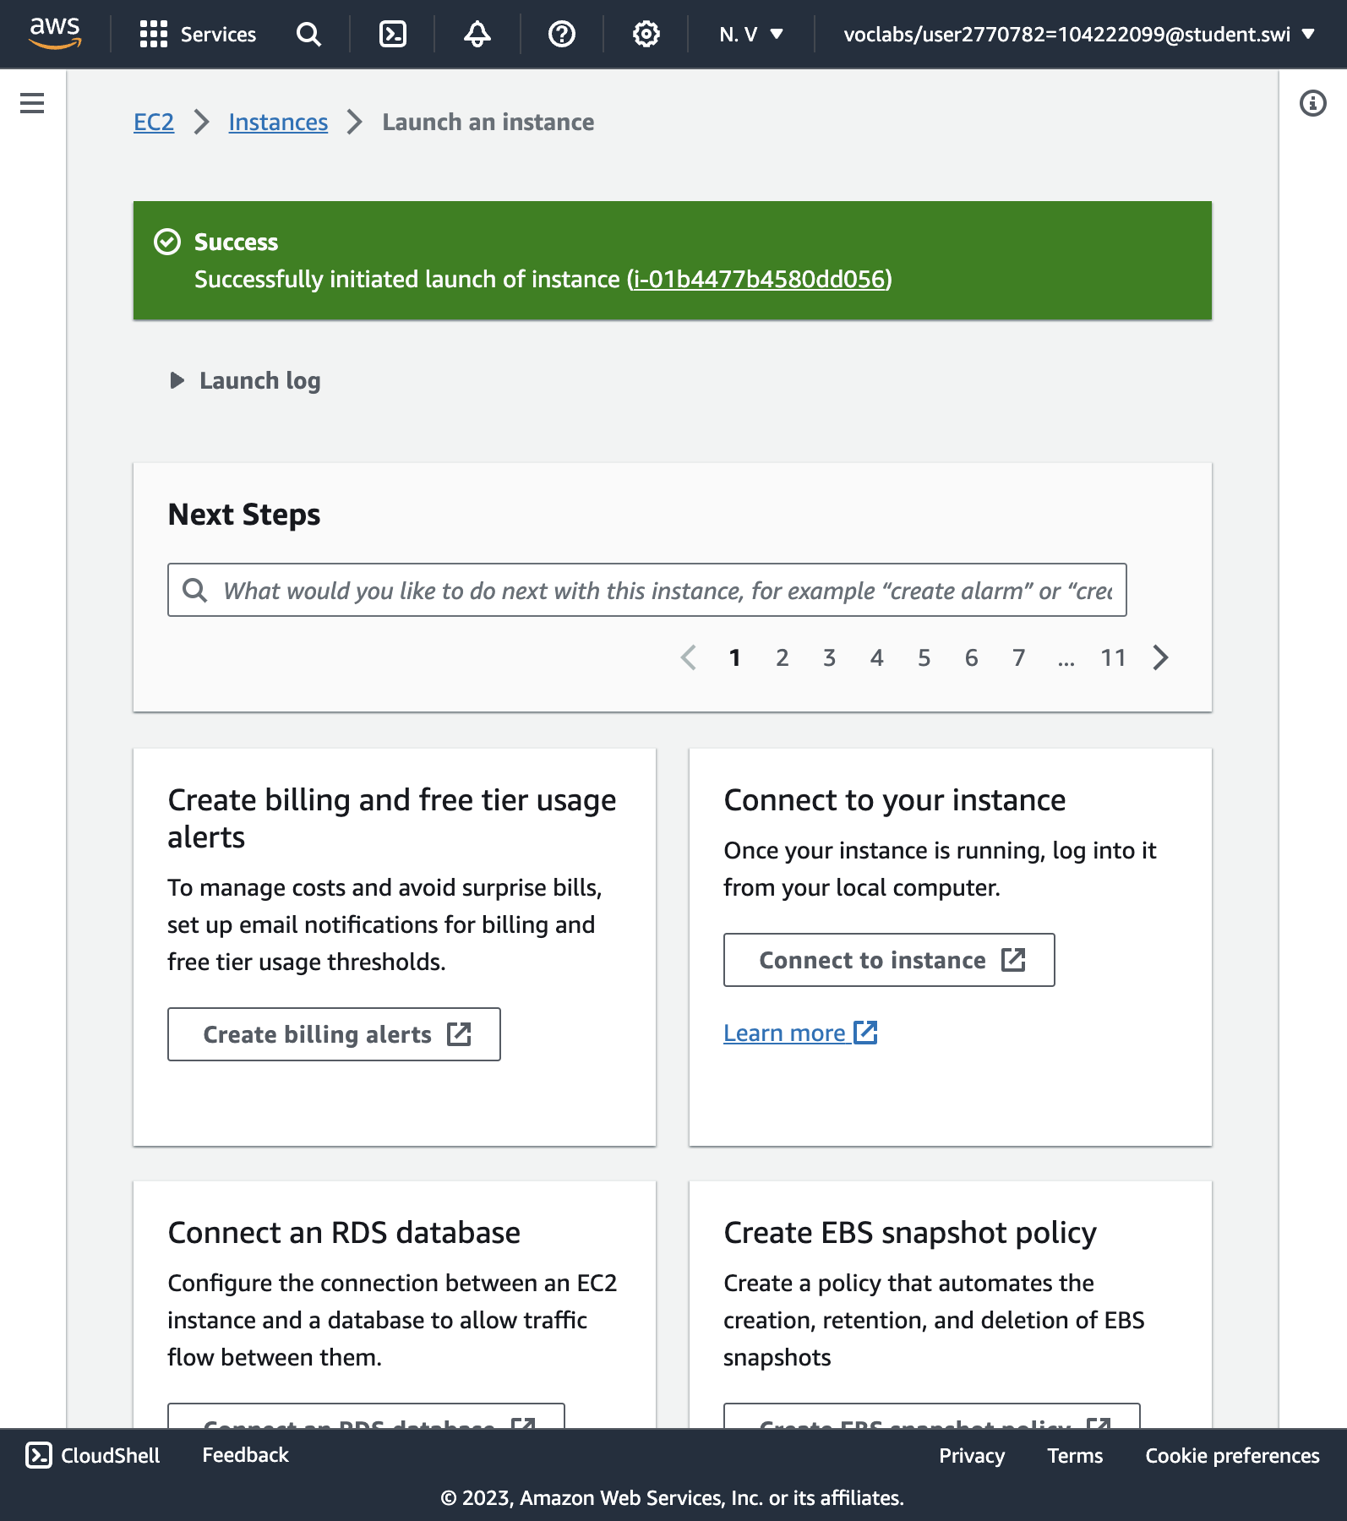

Successfully initiated launch of instance

45. Wait until **Web Server 1** shows ***2/2 checks passed*** in the **Status check** column.

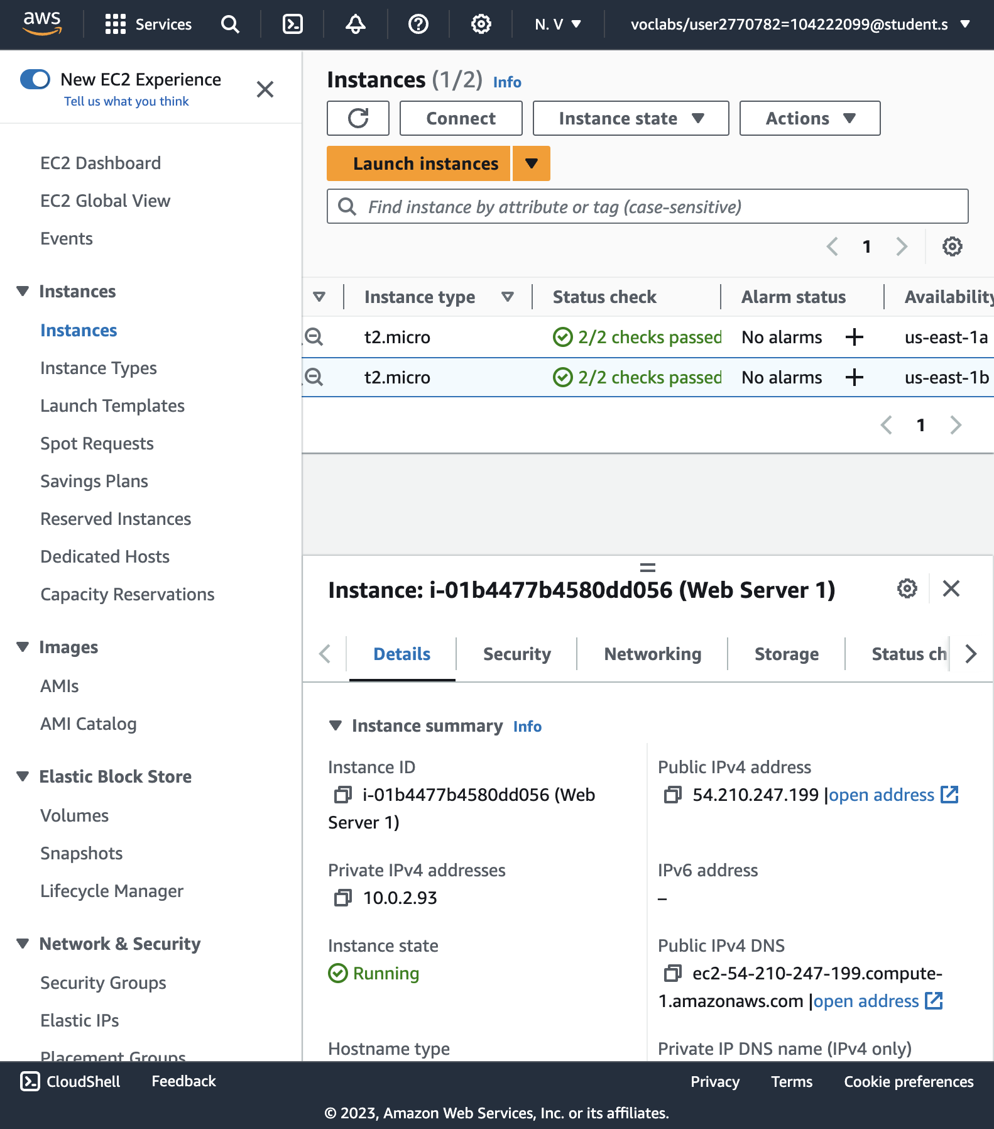

Status check: ***2/2 checks passed***.

47+48. Copy the Public IPv4 DNS value shown in the Details tab at the bottom of the page. Open a new web browser tab, paste the Public DNS value and press Enter. You should see a web page displaying the AWS logo and instance meta-data values.

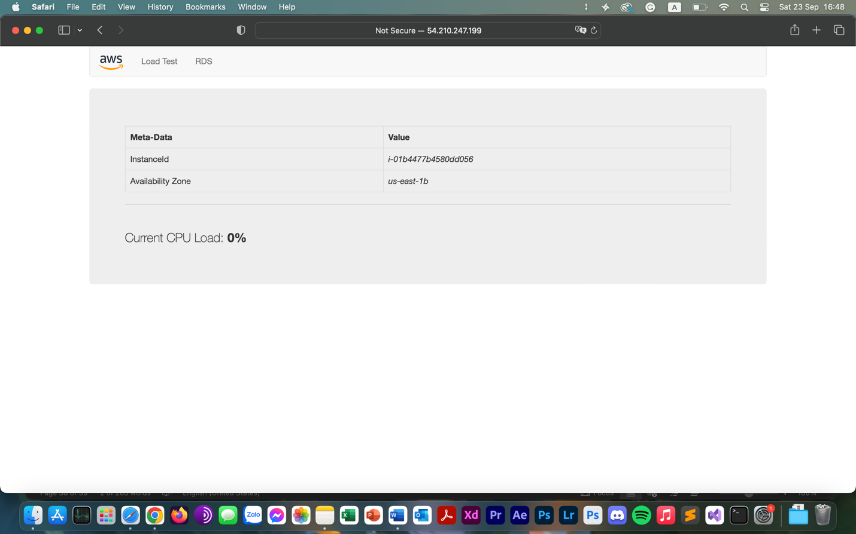

Web page displaying the AWS logo and instance meta-data values.

50. End lab.

